

Requirements Specification and Systems Design BAPERS

IN2018-TeamProject

Gerda Morockaite & co.

Liu liu megatech

[Company address]

Table of Contents

1 Preface 4

1.1 Purpose and scope of the document (what is it and what it is not) 4

1.2 intended audience and Reading suggestions 4

1.3 History of the Document 4

2 Introduction 4

3 Glossary 5

4 System requirements 5

4.1 Purpose and Scope of the System 5

5 System Models 6

5.1 Use Case Diagram 6

6 Design Class 13

6.1 Package Diagram 13

6.2 Simplified Design Class Diagram 14

6.2.1 14

6.3 Detailed Design 15

7 Use Case Indexing 16

ADMIN 17

ACCT 19

CUST 22

REPORTS 24

PAYMENT 25

8 Use Case Specifications 28

Generate Letter 29

Add User 30

Automatic Backup 31

Update Existing Task 31

Upgrade Customer Account 32

Print Late Reminder 33

Login 34

Generate Reports 35

Update Job Status 35

9. Systems Evolution 36

10. Appendices 36

11. Hardware and Software configuration 36

11.1 Hardware minimal requirements 36

11.2 Operating Systems: 36

11.3 Additional Software 36

12. Database 37

12.1 ER Diagram 37

12.2 SQL schema 37

12.3 Reports 53

12.3.1 Summary Performance Report 53

12.3.2 Individual performance report 54

# Preface

## Purpose and scope of the document (what is it and what it is not)

This is a systems requirements document for the BAPERS Software which covers the requirements with appropriate diagrams to portray the system as a whole. In this document it is discussed how the system shall behave, be implemented and how BIPL staff will be able to interact with it.

This is the not the final document as changes may occur during development.

## Intended Audience and Reading Suggestions

The BIPL staff, Software Developers and Mr Lancaster

## History of the Document

This is a new document, v 1.0

# Introduction

**BIPL** is a photographic laboratory that deals with the work of professional photographers by providing a number of standard jobs

The jobs are made up of one or more standard tasks that are performed in their professional laboratory operated by the staff. Special requests can be added to the job as well as the “urgent status” which is a request by the customer for the job to be completed faster than the original deadline which is usually, within 24 hours. The usual “urgent job” must be completed within 6 hours but the customer can also choose 3 hours for a 100% surcharge. The customer can choose an even faster job but at higher rates.

Currently, **BIPL** can perform 30 standard tasks, each task being uniquely identified and carried out in a specific location in the laboratory.

Each task has an ID, a description, a location in the laboratory, a price and a duration. Once a task is completed, the product is placed in a specific shelf, from where it can be taken for further processing or given to the customer, if completed. Each task has a specific shelf slot.

Most **BIPL** jobs are priced below 400 GBP, operating at a high-turnover, low profit margin level, with hundreds of jobs operating or pending at the same time.

Whenever a new job is placed, it has to be associated to an existing customer or a newly created one.

# Glossary

**BAPERS:** Bloomsbury’s Automated Process Execution Recording System

**Actor:** A human or an external system interacting with BAPERS, e.g. Office Manager and Receptionist

**BIPL:** Bloomsbury’s Image Processing Laboratory

**CUST:** Customer package in BAPERS system

**ACCT:** Account Package in BAPERS system

**ADMIN:** Admin package in BAPERS system

**PAYMENT:** Payment package in BAPERS system

**REPORTS:** Reports package in BAPERS system

**GUI:** A graphical user interface is a human-computer interface that uses windows, icons and menus and which can be manipulated by a mouse Icons are used both on the desktop and within application

**ER diagram**: Entity Relationship Diagram is a graphical representation of an information system that shows the relationship between people, objects, places, concepts or events within that system.

**Design class Diagram:** a model element that describes behavioural and structure features

**Use case:** A basic interaction of a system with an actor.

**UML:** Unified Modelling Language

# System requirements

## Purpose and Scope of the System

This section provides more details on system’s functionality and the intended audience are the system architects, designers and developers responsible for the implementation of BAPERS. Since we use UML, which requires a degree of specific expert knowledge, we do not expect this section to be immediately useful to BIPL Staff and Mr Lancaster but would like to encourage them to review and comment, if possible.

The current system is a paper-based system whereby all records of payment, customer accounts and reports are hand written. The initial process of placing a job within the Company remains the same as specified in the requirements and the interactions with staff and particular functions remain the same with the requirements. The purpose of this document is to develop a computerised based system that will be able to track jobs, tasks, record payments, store customer details and store reports in a database.

# System Models

## Use Case Diagram

In the following diagrams, it has been created in packages to represent the different subsystems of BAPERS. We have 6 packages which include ADMIN, CUST, PROC, ACCT, PAYMENT and REPORTS.

#### ADMIN

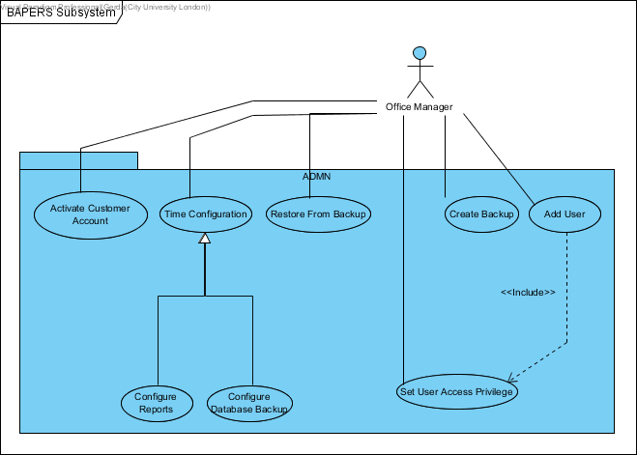

**Use Case descriptions:**

**Activate Customer Account:** Reactivates customer account marked as ‘in default’.

**Time Configuration:** Configures the periodicity of automatic functions.

**Configure Reports:** Changes the frequency of reports.

**Configure Database Backup:** Changes the frequency of automatic backups.

**Create Backup:** Manually creates/overwrites system backup.

**Add User:** Creates a user account for BAPERS.

**Set User Access Privilege:** Sets up user access privileges.

**Restore from Backup:** Restores BAPERS from an existing backup.

#### CUST

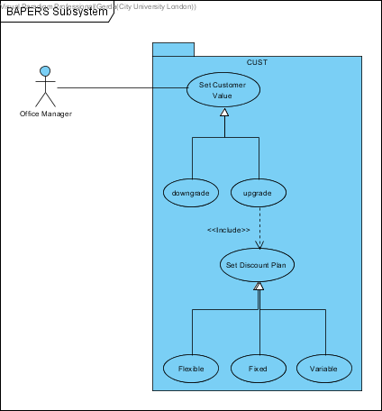

**Use Case descriptions:**

**Set Customer value**: office manager chooses to set a customer to a valued customer

**Downgrade**: office manager can choose to downgrade a customer’s valued status

**Upgrade**: office manager can choose to upgrade a customer’s valued status

**Set discount plan**: when a customer is upgraded, the office manager has the option to set up a discount plan according to how many Jobs/tasks a customer has placed.

**Flexible**: this use case defines the percentage of the discount that depends on the values of the jobs by the same customer accumulated within a calendar month.

**Variable**: this use case defines the percentage of the discount that is set for each task and may vary between the tasks. The value of this discount is calculated and deducted from the value of the job at the time of accepting the job.

**Fixed**: this use case defines the same percentage of discount given to the valued customer for each job. The value of this discount is calculated and deducted from the value of the job at the time of accepting the job.

#### PROC

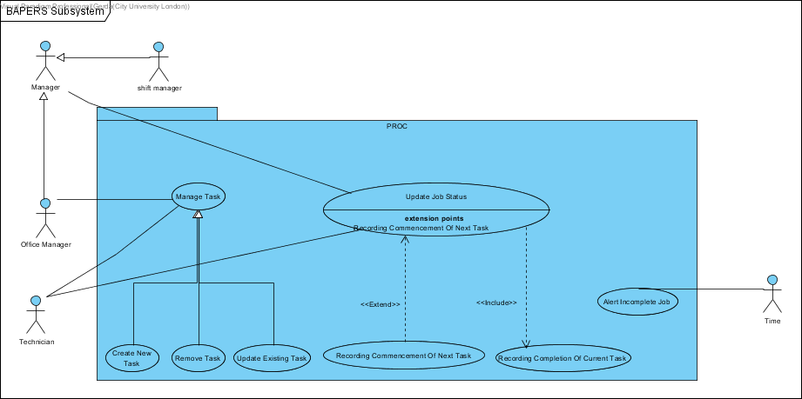

**Use Case descriptions:**

**Manage Task:** Edit the tasks that exist in the system, add or delete them

**Create New Task:** Add a new task to the list of existing tasks

**Remove Task:** Delete a task from the list of existing tasks

**Update Existing Task:** Update any changes made to an existing task

**Update Job Status:** Update the status of an ongoing job and the tasks it has performed or are about to be performed. The commencement and completion of tasks are recorded here

**Alert Incomplete Job:** Alerts the customer if the job they placed cannot be completed of the job at the time of accepting the job.

**Recording Commencement of Next task:** System records the start of the next task

**Recording Completion of Current Task:** System records completion of the current task

#### ACCT

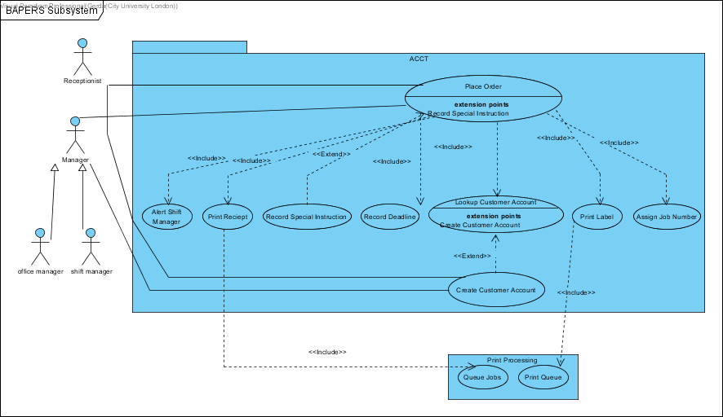

**Use Case Descriptions:**

**Place Order:** The actor (Managers or Receptionist) placing the order on behalf of the customers.

**Alert Shift Manager:** To alert the shift manager that there is a new job arrived and should be processed.

**Print Receipt:** Print a receipt for the customer about the job he/she ordered.

**Record Special Instruction:** Record additional requirements from the customer.

**Record Deadline:** Record the required job end time.

**Lookup Customer Account:** Search the customer account in order to identify the identity of the customer.

**Create Customer Account: creating** a new instance of customer account due to the very first order from the new customer.

**Print Label:** Print the label for materials required for job.

**Assign Job Number:** Generate a number for the job which is unique compare to other jobs.

**Queue Jobs:** it adds a new print job to the print queue

**Print Queue:** the print queue prints all items on the print queue

#### PAYMENT

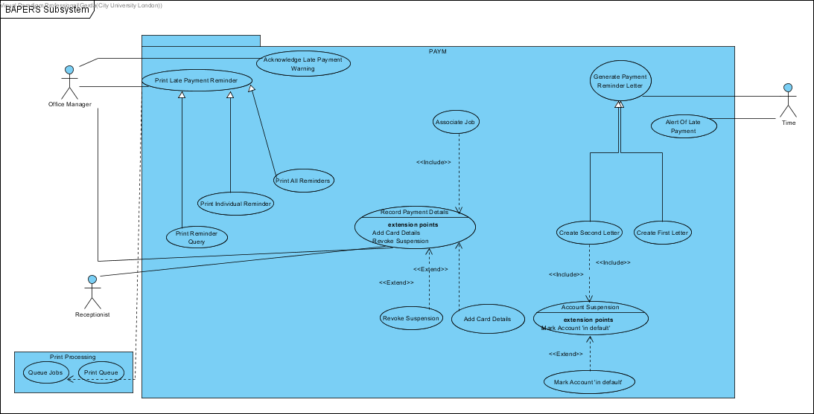

**Use Case Descriptions:**

**Print Late Payment Reminder:** when a late payment is made, a late payment reminder is created which can then be printed by the office managers discretion.

**Print Reminder Query:** this use case gives the option/functionality to the office manager to print whichever late payment reminder they want.

**Print Individual Reminder:** This prints the late payment reminder for a single job. It prints the latest job reminder.

**Print All Reminders:** Prints all the late reminders that have been stored.

**Acknowledge Late Payment Warning:** the office manager gets alerts of late payments to his/her computer, and the office manager acknowledges these late payment warnings.

**Record Payment Details:** once the customer pays for the completion of the job payment method and details are recorded.

**Revoke Suspension:** when a customer account is suspended, and a payment is made from that account. The suspension on that account is revoked and the account is reactivated automatically.

**Add Card Details:** if the customer is paying with card, card details are recorded such as expiry date, type and last 4 digits.

**Associate Job:** each payment needs to be associated with a job. This checks the payment with the job ensuring the payment is for the right job.

**Generate Payment Reminder Letter:** triggered automatically, when valued customers are unable to clear the outstanding balance, a late payment reminder letter is generated.

**Create First Letter:** generates the first late payment letter.

**Create Second Letter:** generates the second late payment letter.

**Account Suspension:** after the second letter is created the account associated with it is suspended automatically.

**Mark Account “in default”:** a month after the second letter has been sent and the outstanding balance has not been cleared the system marks that account as “in default” automatically.

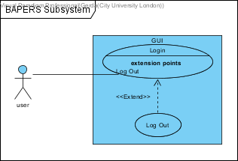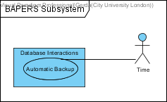**Alert of Late Payment:** automatic alerts of late payments are shown to the office manager as pop-up windows in 15 minutes intervals.

User will be able to interact through a GUI and be able to login/logout and access BAPERS, more details about the design of the GUI is discussed in 10.1 of the document.

Time also interacts with the database as a separate subsystem producing automatic backups

*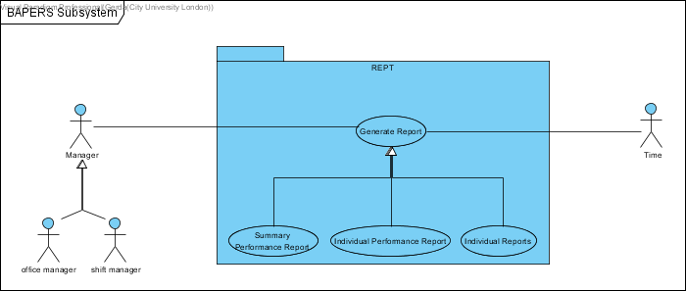 R*EPORT

**Use Case Descriptions:**

**Generate Report:** Generate a report according to the type according to the user (Office Manager) chosen.

**Summary Performance Report:** Generate the report about summary performance with the data’s stores in the database.

**Individual Performance Report:** Generate the report about individual performance with the data’s stores in the database.

**Individual Report:** Generate the report about individual with the data’s stores in the database.

# Design Class

## Package Diagram

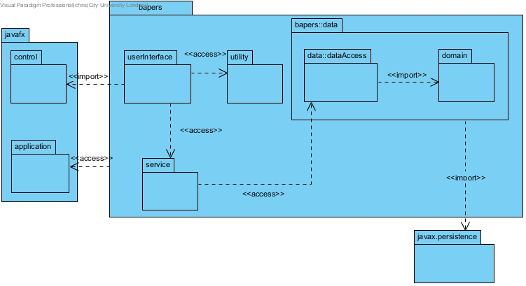

DB connectivity is modelled with the expectation of using the eclipselink library, which is an implementation of JPA, hence the import to javax.persistence. I have simplified the diagram by not showing the persistence unit, as this will be autogenerated by the chosen IDE, making it redundant to show it in the class diagram.

The persistence unit will need to include the following property: <property name="javax.persistence.jdbc.url" value="jdbc:mysql://localhost:3306/bapers?zeroDateTimeBehavior=convertToNull&amp;autoReconnect=true&amp;useSSL=true"/>

The userInterface will utilise javaFX; each form will have three separate files, a bapers::fxml::form.fxml, bapers::styles::form.css and bapers::FormController.java. The fxml file details objects within the form, and their respective location, and the controller class will describe the behaviour of the forms objects. However, for the sake of brevity, I have simplified this for the class diagram by bundling all three files into a single boundary class, and making the userInteface package, where they will be stored

## Simplified Design Class Diagram

The following diagram presents the full class diagram; however, all classes have been stripped of their members. This is to concisely show all associations. Full details will be provided in section 6.3.

Please note that the javax.persistence package appears more than once. This was to allow for neater formatting of the diagram, all repeated instances should be treated as part of the same package. This also applies to any other repeated packages/classes.

### 

This diagram excludes all entities from the bapers::data::domain package, as the associations for that package will be shown in the detailed diagram in section 1.3.

## Detailed Design

# Use Case Indexing

In this section, a list is created to rank the most important use cases we believe are necessary for the functionality of BAPERS. We ranked importance based on how the use case affects the systems functionality overall.

1 being the biggest priority and 56 being the least.

|  |  |
| --- | --- |
| UC priority number | Use Case |
| 1 | Place Order |
| 3 | Create Customer Account |
| 2 | Lookup Customer Account |
| 4 | Record Payment Details |
| 5 | Log in |
| 6 | Update Job Status |
| 7 | Print Late Payment Reminder |
| 8 | Add User |
| 9 | Automatic Back-up |
| 10 | Create Second Letter |
| 11 | Update Existing Task |
| 12 | Generate Report |
| 13 | Set Customer Value |
| 14 | Log Out |
| 15 | Assign Job Number |
| 16 | Print Label |
| 17 | Record Deadline |
| 18 | Record Completion Of Current Task |
| 19 | Record Commencement Of Next Task |
| 20 | Add Card Details |
| 21 | Create New Task |
| 22 | Manage Task |
| 23 | Alert Incomplete Job |
| 24 | Create Backup |
| 25 | Restore From Backup |
| 26 | Configure Database Backup |
| 27 | Associate Job |
| 28 | Time Configuration |
| 29 | Queue Job |
| 30 | Alert Of Late Payment |
| 31 | Acknowledge Late Payment Warning |
| 32 | Generate Payment Reminder Letter |
| 33 | Create First Letter |
| 34 | Print Individual Reminder |
| 35 | Make Account “In Default” |
| 36 | Print Reminder Query |
| 37 | Print All Reminders |
| 38 | Activate Customer Account |
| 39 | Account Suspension |
| 40 | Record Special Instructions |
| 41 | Print Receipt |
| 42 | Set User Access Privilege |
| 43 | Alert Shift Manager |
| 44 | Print Queue |
| 45 | Configure Reports |
| 46 | Revoke Suspension |
| 47 | Individual Performance Reports |
| 48 | Summary Performance Reports |
| 49 | Individual Reports |
| 50 | Remove Task |
| 51 | Set Discount Plan |
| 52 | Upgrade |
| 53 | Downgrade |
| 54 | Fixed Discount |
| 55 | Variable Discount |
| 56 | Flexible Discount |

The following descriptions have been made to describe the impact of all use cases in terms of Budget, resources and time.

### ADMIN

* ***Activate Customer Account***: Reactivates customer account marked as ‘in default’.
  + The importance of this use case is high because this enables the customer account to be reactivated and useable. The risk of not having this use case means that we would have idle customer accounts in our database, which takes money for space and those customers with that account would not be able to demand any more to-do jobs until this is fixed. This is also a potential risk to push our customers away.
* ***Time Configuration:*** Configures the periodicity of automatic functions.
  + This is important for all automatic timely events and functions that take place within the system. The reason being that this use case sets the time for those functions to occur. Doing this it will ensure that all databases and reports will be backed up automatically and the latest versions are available in case of data loss or server downs. Also, this is helpful because it is very possible that the users forget to back up the data manually thus, this removes that human error. If this was not to be implemented correctly this could lead to loss of access to specific data when need in case of services down such as database server downs.
* ***Configure Reports:*** Changes the frequency of reports.
  + This is directly linked to the Time Configuration use case as initially it is setup from that use case, but this use case allows you to change the automatic backup of the reports. This is an appropriate use case that can be used to automatically backup the reports to meet your requirements. Moreover, this is very useful because it is possible that the users forget to create the report backup and they would be able to keep track of progress and report backups.
* ***Configure Database Backup:*** Changes the frequency of automatic backups.
  + This is directly linked to the Time Configuration use case as initially it is setup from that use case, but this use case allows you to configure the automatic backup of the database. This is important as you need regular updates of the database in case of data loss or inaccessibility of the database. That way you don’t lose all the information that you had in your database. Moreover, it is good to have automatic backups as it is very likely for the users to forget to create regular backups and they would be able to monitor and keep track of their database and can be used for analysis.
* ***Create Backup:*** Manually creates/overwrites system backup.
  + Being able to create a backup when necessary is important. The risks of not being able to do this include the fact that if your servers/databases were to crash or fail, our system would be down until fixed. However, with a backed-up database we can continue to work with the latest information from the backup. Having the system down will result in a major financial loss as for that period of time the system was not being used. This would also be more time efficient because as we continue to work of the backup we can proceed to fixing the main server. Also, this allows the backing up any important data as soon as it is entered in the system, rather than having to wait for the timely backups.
* ***Add User:*** Creates a user account for BAPERS.
  + The risk of not implementing this would include the fact that you would have no users for the system thus no coordination and no access to the software functions. To be able to use certain functions/the system you are required to have an account and without it your access will technically be blocked and unusable. This would result to you having to continue to process jobs, tasks etc. the entire process as you have done prior to this software, which is time consuming and much costlier.
* ***Set User Access Privilege:*** Sets up user access privileges.
  + This is important to set what each user can do in the system. What access they have, what functions they can use, what their responsibilities are etc. The risk of not having this can be drastic, for example if all users have access to changing a job status/demands and everyone is changing those requirements and statuses this can cause confusion between the employees and can effect the completion of the job. Which will result in unsatisfied customers and we would have to amend the job to satisfaction, which will result in more cost and time. Therefore, it is important to set user privileges that allows access according to your user account type.
* ***Restore from Backup:*** Restores BAPERS from an existing backup.
  + This follows from the Create Backup use case. If we encounter a problem with the system/ system data and it is no longer useable we need to be able to restore the system to a working backup so that it does not halt the jobs that need to be done, because consequently if we do not have this backup functionality this will result in money loss, data loss, server space loss and dissatisfied customers. Making this use case very important.

### ACCT

* ***Place Order:*** The actor (Managers or Receptionist) placing the order on behalf of the customers.
  + The risks involved in not having this use case implemented properly is that no job will be entered into the system thus the system would be useless as it won’t be used, as a job is required to be processed and go through all the other necessary functions to complete a job. This would result in a waste of database space and money as we paid for it, but it is not being used. Moreover, customers would be dissatisfied with uncompleted jobs and a waste of their time, which would push customers away.
* ***Alert Shift Manager:*** To alert the shift manager there is a new job arrive and should be process.
  + This is an important use case to be implemented as it relays information to one of the heads of the managers with high privileges in the system, the shift manager. If this use case was not to be implemented properly, this would mean that the shift manager would not be notified on the new jobs that come in and he would not redirect them, manage them (oversee them) and would not be able to process them. Moreover, this can cause confusion of unknown jobs being entered into the system which the manager may think the system needs checking which takes time and money, so wouldn’t be efficient. Also, this would leave a gap in his knowledge of processing jobs which can cause problems for him/her when asked questions or talking to customers.
* ***Print Receipt:*** Print a receipt for the customer about the job he/she order.
  + The risk of not having this use case implemented means that the customer would not have solid proof of the job order that they have given BILP. Moreover, it’s important for the business to have proof of the jobs they have taken in case of any legal issues or customer complaints, they can refer to the receipts to counter their arguments. If this use case was not to be implemented correctly this could have a negative impact on the income and potentially time.
* ***Record Special Instruction:*** Record additional requirement from the customer.
  + This is a necessary additional functionality to enable customers to have their input on certain tasks and must be implemented correctly. If this was not implemented there is the risk of the tasks not being completed to the customer satisfaction and having missed out key elements that is required to complete the job. This can cause customers wanting a refund as expectations were not met and to reprocess the job (finishing the job by adding the missed-out details), which will take more time and can halt taking in more jobs. This can have a negative impact on the income and time efficiency thus making it important that this use case is implemented correctly.
* ***Record Deadline:*** Record the required job end time.
  + Recording the deadline is important for several reasons that involve both the business and the customers. The most important being so that we can deliver the completed job on time to the customer and ensuring that they are satisfied. This in turn will bring them back to our business as they were pleased with the service and quality of the job. If there was no deadline the business could take a time to com

plete it and delivery to customers would be inconsistent which would make them dissatisfied. Furthermore, it doesn’t show an indication of what priority level the job has. This would cost us our time, database space and money negatively.

* ***Lookup Customer Account:*** Search the customer account in order to identify the identity of the customer.
  + This is an essential use case that needs to be implemented correctly otherwise this can risk creating duplicated customer accounts and unmatched/linked jobs, which will create confusion in the team and take up more database space and time as more accounts are being made than necessary and searched. Moreover, then one job could be linked to multiple customer accounts which cannot happen. Being able to search up customers gives us the ability to search valuable information that is associated with that customer. Thus, it is important to ensure this use case is implemented correctly.
* ***Create Customer Account:*** creating a new instance of customer account due to the very first order from the new customer.
  + This is closely linked to the Lookup Customer Account use case and is very important. The risks of this not being implemented correctly include that jobs given to BILP will have no customer associated with it, meaning that the team would not know who these jobs belong to. This can cause major confusion and can potentially lead to not doing the job as it belongs to no one. Moreover, there would be no data/information about the customer so there would be no way to contact them or get payed or get other specific details. Therefore, it is important that this is conducted correctly and linked to one customer and their jobs only.
* ***Print Label:*** Print the label for materials required for job.
  + The risk of this not being implemented include that the job cannot be completed as the teams updating/doing the job will not know what the customer wanted/what materials are required, thus don’t know what to do to the picture or what is required to complete the process. This will affect team coordination and time as constant communication will be required to answer queries they will have about the job and the materials required.
* ***Assign Job Number:*** Generate a number for the job which is unique compare to other jobs.
  + This is important to help coordinate the job pool. This will also allow the team to access jobs easier by just calling the job number rather than the job name or customer associated with it. This is more time efficient. Alternatively, this risks job confusion with other jobs and can make it less time efficient if this is not implemented.

### CUST

* ***Set Customer value:*** office manager chooses to set a customer to a valued customer
  + This functionality is important to be implemented because there are other functions that can be carried out after this has been done. The risk of this not being implemented correctly effects the types of discount that the customer can get, as only when a customer is valued can they be given a discount plan and other functions would not be used thus taking up more space and code that is not used.
* ***Downgrade:*** office manager can choose to downgrade a customer’s valued status
  + This is directly linked to the Set Customer value use case. Its important that this is implemented correctly so that the manager can change a customer account from valued to non-valued. This is important because if this was not available customers that became valued customers would stay valued customers even if they don’t reach the requirements for the valued customer status. Thus, they could still have the discounts which would result in the company/business making a loss which is a major risk therefore, this needs to be implemented correctly.
* ***Upgrade:*** office manager can choose to upgrade a customer’s valued status
  + This is directly linked to the Downgrade and Set Customer value use cases. This is important and must be implemented because this is the use case that triggers the other use cases. Not implementing this will mean that we are unable to update the valued status of the customer which will cause risks and problems as explained in the other two related use cases.
* ***Set discount plan:*** when a customer is upgraded, the office manager has the option to set up a discount plan according to how many Jobs/tasks a customer has placed.
  + When a customer account is upgraded to a valued customer account they then get a discount plan. This use case sets the discount plan to that account therefore is a necessity. If this use case was not to be implemented correctly this would lead to the manager not being able to give the valued customer a discount plan which can then lead to unvalued customers, consequently leading to less customers and dissatisfaction. Moreover, it would make the previous three use cases useless (Set Customer value, Downgrade, Upgrade).
* ***Flexible:*** this use case defines the percentage of the discount that depends on the values of the jobs by the same customer accumulated within a calendar month.
* ***Variable:*** this use case defines the percentage of the discount that is set for each task and may vary between the tasks. The value of this discount is calculated and deducted from the value of the job at the time of accepting the job.
* ***Fixed:*** this use case defines the same percentage of discount given to the valued customer for each job. The value of this discount is calculated and deducted from the value of the job at the time of accepting the job.

These are the various discount plans use cases that are available to the manager than he can set for the valued customers. These use cases are directly linked to the Set discount plan use case as that use case then refers to one of these for implementation. If these are not implemented correctly it would make the Set discount plan use case useless as there would be no discount plan that can be set for the valued customer. Moreover, this would also be a waste of memory/space as it is a use case that would not be able to complete its functionality. Therefore, to avoid this risk it is important that these use cases are implemented correctly.

PROC

* ***Manage Task:*** Edit the tasks that exist in the system, add or delete them
* The risks associated with this use case is that if we are unable to manage tasks then no changes can be made to tasks for future jobs therefore when the system evolves we will not have a functionality that can handle this so it is also essential we can manage tasks.
* ***Create new task****:* Add a new task to the list of existing tasks
* As technology improves customers will come in with special requirements, so we will need to be able to add this functionality, if the company didn’t have this then it would result in loss of customers as we cannot add in new tasks that they may require.
* ***Remove tasks:*** Delete a task from the list of existing tasks
* If there are too many tasks or if there are tasks that aren’t used as much then this functionality would be necessary. The risks aren’t as high for this use case as it is for create new task.
* ***Update existing task:*** Update any changes made to an existing task
* the risks associated with this functionality is that if changes cannot be made to a particular task then it may affect the job overall therefore leading to money loss and time as jobs end up being incomplete and customers will remain unhappy.
* ***Update Job Status:*** Update the status of an ongoing job and the tasks it has performed or are about to be performed. The commencement and completion of tasks are recorded here
* The risks associated with this use case is that the technician and shift manager will be unable to detect the status of where the job is within the process therefore making it difficult to finish the job itself if they cannot update it. There will be no track of progress made and this will waste a lot of time.
* ***Alert incomplete job:*** Alerts the customer if the job they placed cannot be completed
* The risk associated with this is that the shift manager and technician will be unable to detect incomplete jobs so this may lead to complaints by customer and loss in money as we are unable to keep track of which jobs have been processed and which jobs haven’t.
* ***Recording Commencement of Next task:*** System records the start of the next task
* The risk associated with this use case is that if we do not show that a job has been completed by recording its completion then the system will never be able to let staff know when and which task it is on. This is an important use case to implement as it is an automatic response that shows the progress of tasks in a job and lets staff know when the next task is starting. When a completion is set then we know which tasks have been completed and not so if any errors occur the system will be able to detect it. It also reduces human error as staff cannot keep up with many jobs and tasks.
* ***Recording of current task:*** System records completion of the current task
* Similar to the commencement of next task, it gives a recording of where a task it at and reduces human errors. These use cases are important as we may have urgent jobs that must be taken therefore we must record every single job and task that takes place and its completion and if it not completed then it will be placed in a shelf slot ready to be processed again the following day.

### REPORTS

* ***Generate Report:*** Generate a report according to the type according to the user (Office Manager) chosen.
  + This use case is important as it generates specific reports that are required by the office manager. Without this use case the office manager would not have any reports thus would not be able to monitor his/her employees and customers progress and work and would not be able to make specific plans when required. Moreover, he would be less aware of his employees, customers and the jobs that are being given and taken by BILP and how they are progressing. If this was not to be implemented correctly there would be no reports generated and then the office manager would not be able to monitor the progress thus would not be able to take any decisive actions when required as he would not have the information required. Moreover, it would cost more if the reports would have to be made manually and would be more time consuming, thus it is important that this use case is implemented as the reports are made automatically.
* ***Individual Report:*** Generate the report about individual with the data’s stores in the database.
  + This use case is directly linked to the Generate Report use case as this is a type of report that would be generated thus would call for the implementation of this use case to create the report. This report provides the jobs brought in by a particular customer and presents it in the report and without it the manager would have no easy and compact means of checking and having a hard copy of this information. Not having implemented this use case the manager would have to search on the system which would be less time efficient. Moreover, this would also be a waste of memory/space as it is a use case that would not be able to complete its functionality. Thus, it is important that this is implemented correctly.
* ***Summary Performance Report:*** Generate the report about summary performance with the data’s stores in the database.
* ***Individual Performance Report:*** Generate the report about individual performance with the data’s stores in the database.

These two use cases are directly linked to the Generate Report use case as these are the different types of reports that can be generated by the office manager and call for their implementation. If these are not implemented correctly it would make the Generate Report use case useless as there would be no report available. Moreover, this would also be a waste of memory/space as it is a use case that would not be able to complete its functionality. Consequently, if they had to make these reports manually it would be more cost and time consuming. Therefore, to avoid this risk it is important that these use cases are created and implemented correctly

### PAYMENT

* ***Print late payment reminder:*** when a late payment is made, a late payment reminder is created which can then be printed by the office managers discretion.
* without a reminder, payments will be missed by customers therefore the company will be unaware of who has paid therefore the risk is that they are losing out on money.
* ***Print reminder query:*** this use case gives the option/functionality to the office manager to print whichever late payment reminder they want.
* the risk associated with this use case isn’t as high but the use case functionality is required as they will need access to any letters that they need to be able to check if they need to downgrade a customer’s value.
* ***Print all reminders:*** Prints all the late reminders that have been stored.
* the risks associated with this use case is that when the office manager will like to access all reminders, he will be unable to if they are lost in the database
* ***Acknowledge late payment warning:*** the office manager gets alerts of late payments to his/her computer, and the office manager acknowledges these late payment warnings.
* risks associated with this use case is that if no warning is implemented the office manager will be unable to track which customers haven’t paid for their jobs therefore resulting in loss of money but also time as they will have to search through the whole database to lookup customer details.
* ***Record payment details:*** once the customer pays for the completion of the job payment method and details are recorded.
* the risks associated with this use case is that we will not have any record of customer details therefore if there are customers he wants to pay by card, we will not have that functionality thus resulting in loss of customers.
* ***Revoke suspension:*** when a customer account is suspended, and a payment is made from that account. The suspension on that account is revoked and the account is reactivated automatically.
* the risks associated with this functionality is that if we do not have an automated revoke suspension then some customers account will not be reactivated once they have made a payment which may lead to customers unhappy with the service and also there will be more jobs for the BAPERS staff to keep up with as it’s a functionality they must keep track of.
* ***Add Card Details:*** if the customer is paying with card, card details are recorded such as expiry date, type and last 4 digits.
  + It is important to have the required payment details when conducting a payment. If this use case was not to be implemented correctly then the payment process would not be conducted correctly as certain details are required to conduct a card payment. Moreover, it would be less efficient for future card payments from that customer as the same details would be required, whereas if they were stored the first time they already have the necessary details. This use case is required as there are necessary details required for card payment and without them cannot be conducted, thus it is important that this use case is implemented correctly.
* ***Associate Job:*** each payment needs to be associated with a job. This checks the payment with the job ensuring the payment is for the right job.
  + This is a necessity because it is imperative that the payment that is being conducted is for the right job. Without this use case it risks that payments are being for made for different jobs and there would be no coordination of payments, jobs and can cause confusion within the team. It also risks that a lot of time could be wasted due to incorrect payments and having to retract and locate the correct jobs. Moreover, this can push customers away and if the wrong payment is done customer would want and need refunds which is bad for the company.
* ***Generate Payment Reminder Letter:***triggered automatically, when valued customers are unable to clear the outstanding balance, a late payment reminder letter is generated.
  + This use case it important to ensure that the company can pursue late payments/missed payments so that they receive their money but is also good proof in case of if lawful actions need to be taken. This is an automatic use case that will be used to notify customers of their late payments and inform them of the necessity of their payments. Without this use case the company would not be able to purse them, and the customers would not feel as obligated to pay on time as they would think that the company is lenient and would not take any actions against it. Therefore, it is important to implement this use case to ensure that all payments are being made and overdue payments are being tackled appropriately.
* ***Create First Letter:*** generates the first late payment letter.
  + This use case is directly linked to the Generate Payment Reminder Letter use case as the letter that would be sent needs to be created and this is what this use case does. Without this use case the letter would not be created consequently, the situation cannot be tackled correctly, presenting the same risks as the Generate Payment Letter use case. Moreover, this use case would be useless without the Generate Payment Reminder Letter as that would trigger this use case, so if not implemented correctly it would also be a waste of space in our server/database.
* ***Create Second Letter:*** generates the second late payment letter.
  + This use case is directly linked to the Generate Payment Reminder Letter and Create First Letter use case as the second letter that would be sent needs to be created and this is what this use case does. Without this use case the second letter that needs to be sent would not be created thus the customer wouldn’t not be notified and the following required action to this situation would not be carried out/not with the customers awareness. Moreover, this use case if not implemented correctly would waste space in the database/server as the letter would not be created and if the Generate Payment Reminder Letter and Create First Letter use case are not implemented correctly this would still be a waste of space as this use case is directly linked with those use cases. Thus, it is important that this use case and the other related to this are implemented correctly.
* ***Account Suspension:*** after the second letter is created the account associated with it is suspended automatically.
  + This is directly linked with the Create Second Letter use case as this use case is only implemented after that one. This is an important use case that must be implemented as this is the action that is taken after giving the customer their final warning on their late payments. Without this use case the customer would be informed about their late payment, but no action would be taken against it which can risk the company status and could possibly make customers think that late payments are okay. Moreover, this would have a negative impact on the revenue of the company and would cost them more to follow the situation and resolve it. Furthermore, both the Create Second Letter and this use case must be implemented correctly otherwise it would also be a waste of space in the database as they wouldn’t be called.
* ***Mark Account “in default”:*** a month after the second letter has been sent and the outstanding balance has not been cleared the system marks that account as “in default” automatically.
  + This is an important use case needed in the system so that the company knows which customers/accounts they need to consider taking legal actions against. This use case is directly linked to the Account Suspension use case as after a period this use case is activated. Moreover, if this was not to be implemented no account would be put into the “in default” state thus when the function to show all the “in default” accounts is called it would provide no results rendering that use case and this one useless to and a waste of space in the database. Thus, it is important that this use case is implemented correctly.
* ***Alert of Late Payment:*** automatic alerts of late payments are shown to the office manager as pop-up windows in 15 minutes intervals.
  + The risk of this use case not being implemented correctly means that the office manager would not be notified of any overdue payments that have been made by the customers. Consequently, he would not know when and who to take legal actions against if/when required. Therefore, it is important that this is implemented correctly to ensure that the office manager is up to date with payment information and can act upon it.

### GUI

* ***Login:*** The user logins to BAPERS
* The risk of not implementing this use case correctly means users such as office manager and receptionist will be unable to login therefore leading to no access to any functions.
* ***Logout:*** The user logouts of BAPERS
* It is necessary to implement this as users need to be able to logout of the system so other users who do not have user access privileges will not be able to get in. This is for the purpose of security and may be harmful to the company.

# Use Case Specifications

This section includes the 10 key use case specifications that were made for BAPERS

*Record payment*

|  |  |
| --- | --- |
| **Use Case ID: 4** | **Use Case:** Record Payment Details |
| **Brief Description:** Once a customer makes a payment with BAPERS, a record of the payment is then stored in the local memory of the machine running the system and then the record is stored in the database. | |
| **Primary Actors:** Office Manager, Receptionist | |
| **Secondary Actors:** Database Server | |
| **Preconditions:**   1. The system is operational 2. Either the Office Manager, or the Receptionist is logged into the system and had chosen the GUI option to record a payment from a client. | |
| **Main Flow:**   1. The use case starts when the Office Manager, or receptionist selects Record Payment functionality. 2. The GUI prompts the user to then enter the payment details including: amount paid, whether the payment is card or cash. 3. The GUI then sends the input information to the system, and the system creates a payment object. 4. The system then finds the outstanding (unpaid) jobs for the customer, and adds them to the payment object. 5. The system contacts the Database Server, and sends the payment object to be stored on disk. 6. The system deletes the local payment object.   The system alerts the user that payment has been added. | |
| **Postconditions:**  The database contains a new payment record | |
| **Alternative Flows:**  CardPayment  NoConnectionToServer  UnSuspendAccount | |

|  |  |
| --- | --- |
| **Use Case ID:** N/A | **Use Case:** Record PaymentDetails : CardPayment |
| **Brief Description:** The customer has made a payment with a card, so the card details will be added to the system. | |
| **Primary Actors:** N/A | |
| **Secondary Actors:** N/A | |
| **Preconditions:**   1. The system is operational and Either the Office Manager, or the Receptionist is logged into the system and had chosen the GUI option to record a payment from a client. | |
| **Alternate Flow:**   1. The flow may start at step 2 of the main flow. 2. The GUI prompts the user to enter card details. 3. While (more cards)    1. The user enters card details. 4. The GUI sends the information to the system, and the system then creates a card object, and a payment object. Giving the payment object a reference to the card object.   The flow should resume at step 2 of the main flow. | |
| **Postconditions:**  Local storage contains a Card Details Object, which is referenced by a Payment object. | |

|  |  |
| --- | --- |
| **Use Case ID:** N/A | **Use Case:** RecordPayment:NoConnectionToServer |
| **Brief Description:** A connection cannot be established with the database server, so the operation is aborted. | |
| **Primary Actors:** N/A | |
| **Secondary Actors:** N/A | |
| **Preconditions:**   1. The system is operational and either the Office Manager, or the Receptionist is logged into the system and had chosen the GUI option to record a payment from a client. | |
| **Alternate Flow:**   1. The flow may start at step 5 of the main flow. 2. The system informs the user that no communication channel can be established to the database. | |
| **Postconditions:**  The contents of the database are unchanged | |

### Generate Letter

|  |  |
| --- | --- |
| **Use Case ID:** 10 | **Use Case:** Create 2nd Letter |
| **Brief Description:** BAPERS automatically generate the second letter to the Office Manager which going to be send to the customers. | |
| **Primary Actors:** Time | |
| **Secondary Actors:** Office Manager | |
| **Preconditions**:   1. First letter has been generated and sent to customer. 2. One month after the first letter is sent and payment yet to be received. 3. Office Manager logs into his/her account. | |
| **Main Flow:**   1. The Use case starts when it is a month after the first letter sent out. 2. BAPERS suspend the corresponding customer’s account. 3. BAPERS awaits User with user type Office Manager to Log-in. 4. BAPERS alert the Office Manager and second letter is prepare for him/her to print. 5. BAPERS connects to a printer with existing communication channel. 6. BAPERS inform the Office Manager the print has been completed. | |
| **Postconditions:**  The letter successfully printed out by the Office Manager with no error occur. | |
| **Alternative Flows:**  NoPrinterConnection | |

|  |  |
| --- | --- |
| **Use Case ID:** N/A | **Use Case:** Create 2nd Letter:NoPrinterConnection |
| **Brief Description:** Printing error due to lack of communication with the hardware printer. | |
| **Primary Actors:** N/A | |
| **Secondary Actors:** N/A | |
| **Preconditions**:   1. BAPERS is operational. 2. Office Manager logs into BAPERS. 3. Office Manager receive the alert of the second letter. 4. Office Manager chosen to print the second letter. | |
| **Alternative Flows:**   1. The flow may start at step 5 of the main flow. 2. BAPERS informs the Office Manager that no communication between the printer and the computer can be located. | |
| **Postconditions:**  The letter is not print on demand by the Office Manager. | |

### Add User

|  |  |
| --- | --- |
| **Use Case ID:** 8 | **Use Case:** Add User |
| **Brief Description:** Office Manager creates an user account for BAPERS. | |
| **Primary Actors:** Office Manager | |
| **Secondary Actors:** N/A | |
| **Preconditions**:   1. BAPERS is operational. 2. A user with user type Office Manager has logged into BAPERS. | |
| **Main Flow:**   1. The use case starts when the Office Manager selects “Create User” functionality. 2. Office Manager input details for the user account. 3. Office Manager setting up privileges for the account. 4. BAPERS connect with the database with existing communication channel and send details of the new creation account to it. 5. BAPERS informs Office Manager that a user account has been successfully created. | |
| **Postconditions:**  The database contains the new account details. | |
| **Alternative Flows:**  NoCommunicationChannel | |

|  |  |
| --- | --- |
| **Use Case ID:** N/A | **Use Case:** Create User:NoCommunicationChannel |
| **Brief Description:** Creation error due to lack of communication channel between BAPERS and the database. | |
| **Primary Actors:**  N/A | |
| **Secondary Actors:** N/A | |
| **Preconditions**:   1. BAPERS is operational. 2. User with user type Office Manager logged into BAPERS. 3. Office Manager chosen to create user. | |
| **Alternative Flows:**   1. The flow may start at step 4 of the main flow. 2. BAPERS informs the Office Manager that no communication channel can be located. | |
| **Postconditions:**  User account details in the database remain unchanged. | |

### Automatic Backup

|  |  |
| --- | --- |
| **Use Case ID:** 9 | **Use Case:** Automatic backup |
| **Brief Description:** BAPERS backs up the database server each time period specified. | |
| **Primary Actors:** Time | |
| **Secondary Actors:** | |
| **Preconditions**:   1. BAPERS is operational. 2. Automatic backup period is specified. | |
| **Main Flow:**   1. Use case starts when specified time occurs. 2. BAPERS backs up the Database server. | |
| **Postconditions:**  The database server is backed up/replaces the old backup. | |
| **Alternative Flows:**  NoCommunicationChannel | |

|  |  |
| --- | --- |
| **Use Case ID:** N/A | **Use Case:** Automatic backup:NoCommunicationChannel |
| **Brief Description:** Automatic backup unavailable due to lack of communication channel. | |
| **Primary Actors:** N/A | |
| **Secondary Actors:** N/A | |
| **Preconditions**:   1. BAPERS is operational. 2. Automatic backup period is specified. | |
| **Alternative Flows:**   1. The flow may start at step 2 of the main flow. 2. BAPERS informs the User that no communication channel can be located | |
| **Postconditions:**The database server is not backed up. | |

### Update Existing Task

|  |  |
| --- | --- |
| **Use Case ID:** 11 | **Use Case:** Update existing task |
| **Brief Description:** Edit existing tasks from the task list. | |
| **Primary Actors:** Office manager | |
| **Secondary Actors:** Database server | |
| **Preconditions**:   1. BAPERS is operational. 2. Primary actor is logged in to BAPERS. | |
| **Main Flow:**   1. Use case starts when the User selects “Update existing task” functionality. 2. Tasks are retrieved from the database server 3. User selects a task. 4. User updates the details of the task 5. BAPERS updates the task. 6. BAPERS informs user that the task has been updated. | |
| **Postconditions:**  The database server contains updated task; all previously stored tasks are unchanged. | |
| **Alternative Flows:**  NoCommunicationChannel | |

|  |  |
| --- | --- |
| **Use Case ID:** N/A | **Use Case:** Update existing task:NoCommunicationChannel |
| **Brief Description:** Task updating unavailable due to lack of communication channel. | |
| **Primary Actors:** N/A | |
| **Secondary Actors:** N/A | |
| **Preconditions**:   1. BAPERS is operational. 2. Primary actor is logged in to BAPERS | |
| **Alternative Flows:**   1. The flow may start at step 2 of the main flow. 2. BAPERS informs the User that no communication channel can be located | |
| **Postconditions:**  The content of tasks in database server remains unchanged. | |

### Upgrade Customer Account

|  |  |
| --- | --- |
| **Use Case ID:** 13 | **Use Case:** UpgradeCustomerValue |
| **Brief Description:** Upgrade important customers to the “Valued” status, enabling them to benefit from different discounts. | |
| **Primary Actors:** Office Manager | |
| **Secondary Actors:** Database | |
| **Preconditions**:   1. The system is functional and the Office Manager logs in to the system | |
| **Main Flow:**   1. The Use Case starts when the Office Manager logs into the system 2. The Office Manager accesses the customer list 3. The Office Manager selects the customer 4. The Office Manager clicks the GUI button for upgrading the customer to the “Valued” status 5. When the button is clicked, the system fetches the value from the database 6. The system creates an object into the system where it stores the value 7. The system changes the old value with the new value 8. The data is sent back by the system to the database 9. The database overwrites the old status with the new status. | |
| **Postconditions:**  The database is updated with the new customer status and the customer is eligible for discounts | |
| **Alternative Flows:**  InvalidAccountUpgraded | |

|  |  |
| --- | --- |
| **Use Case ID:** N/A | **Use Case:** UpgradeCustomer Value:InvalidAccountUpgraded |
| **Brief Description:** The system informs the Office Manager that the account he is trying to upgrade is already upgraded | |
| **Primary Actors:** N/A | |
| **Secondary Actors:** N/A | |
| **Preconditions**:   1. The Office Manager has tried upgrading an account that is already upgraded | |
| **Alternative Flows:**   1. Alternative flow begins at step 4 2. The Office Manager clicks the GUI button for updating the user status 3. The system fetches the data from the database 4. The system compares detects that the change already took place 5. The system displays the error message 6. The system does not send any information back to the database and deletes the object created | |
| **Postconditions:**  The database is not modified | |

### Print Late Reminder

|  |  |
| --- | --- |
| **Use Case ID:** 7 | **Use Case:** PrintLatePaymentReminder |
| **Brief Description:** Print the late payment reminder for the customer who did not pay in time for the service. | |
| **Primary Actors:** Office Manager | |
| **Secondary Actors:** N/A | |
| **Preconditions**:   1. The system is functional; the Office Manager logs in to the system and the customer exceeded the payment deadline | |
| **Main Flow:**   1. The screen displays the notification that a customer has exceeded the payment deadline 2. The Office Manager Clicks the GUI button for printing the letter 3. The letter is printed | |
| **Postconditions:**  The Database is updated with the information of a user having a letter printed for | |
| **Alternative Flows:**  PrinterError | |

|  |  |
| --- | --- |
| **Use Case ID:** N/A | **Use Case:** PrintLatePaymentReminder: PrintLatePaymentReminder |
| **Brief Description:** Office manager is unable to print the letters required as a print error occurs | |
| **Primary Actors:** N/A | |
| **Secondary Actors:** N/A | |
| **Preconditions**:   1. The system is functional; the Office Manager logs in to the system and the customer exceeded the payment deadline | |
| **Alternative Flows:**   1. Flow may start at step 2 of the main flow 2. There is a printer error when trying to print the letter | |
| **Postconditions:**  The late reminder message is not printed | |

### Login

|  |  |
| --- | --- |
| **Use Case ID:** 5 | **Use Case:** Login |
| **Brief Description:** The procedure where the users/staff can login to the BAPERS system so that they can use the system and its functions. | |
| **Primary Actors:** Receptionist, Shift Manager, Office Manager, Technician | |
| **Secondary Actors:** Database server | |
| **Preconditions**:   1. System is operational, the system has a secure connection to the database server. 2. The primary actors must be authorised. | |
| **Main Flow:**   1. The use case starts when the user selects the “Login” button. 2. The system opens another page where the user is told to enter their login details in the space provided. 3. The user then presses the login button. 4. The system then searches the database for corresponding login details.    1. Corresponding login details are not found. While not found:       1. System tells user: invalid username or password.       2. System tells user to check and re-enter their username and password.    2. The user then clicks the login button again. 5. User then login 6. Use case completed. | |
| **Postconditions:**  The user login and the software and its functions are accessible to the user. | |
| **Alternative Flows:**  LoginFailed | |

|  |  |
| --- | --- |
| **Use Case ID:** N/A | **Use Case:** Login: LoginFailed |
| **Brief Description:** The system informs the user that login failed due to an incorrect username or password or both. | |
| **Primary Actors:** N/A | |
| **Secondary Actors:** N/A | |
| **Preconditions**:   1. The user entered an incorrect username and/or password, which was not found in the database. | |
| **Alternative Flows:**   1. The alternative flow begins at step 4 of the main step. 2. The system informs the user that invalid details have been provided. | |
| **Postconditions:**  The user is denied access to the system | |

### Generate Reports

|  |  |
| --- | --- |
| **Use Case ID:** 12 | **Use Case:** Generate Report |
| **Brief Description:** Various reports are generated automatically by BAPERS | |
| **Primary Actors:** Time | |
| **Secondary Actors:** Database server | |
| **Preconditions**:   1. BAPERS is operational 2. There is an established connection to the database server. | |
| **Main Flow:**   1. The use case starts when the time triggers the functionality of generating reports. 2. Individual report for the jobs brought in by a particular customer for an arbitrary period is taken. 3. Individual performance report on work undertaken by a member of BIPL staff is generated 4. Summary Performance report for work undertaken by BIPL during day and night shifts is generated. | |
| **Postconditions:**  The generated reports get stored in the database | |
| **Alternative Flows:**  None | |

### Update Job Status

|  |  |
| --- | --- |
| **Use Case ID:** 6 | **Use Case:** Update Job Status |
| **Brief Description:** primary actor updates the status of an ongoing job | |
| **Primary Actors:** Office Manager, Shift Manager, Technician | |
| **Secondary Actors:** N/A | |
| **Preconditions**:   1. The system is operational. 2. The primary actor is already logged in. | |
| **Main Flow:**   1. The use case starts when the Manager or Technician chooses to update the status of the job 2. They can record the completion of the current task which is shown as an include 3. They can also update the system with the commencement of the next task 4. Once updated, the status is recorded and sent back to the database. | |
| **Postconditions:**  Completion of tasks are recorded | |
| **Alternative Flows: None.** | |

# Systems Evolution

The system was developed so that it can further expanded in the future. It allows the implementation of new equipment, having the option to introduce new tasks in the future. The system can be extended to have more option for the user type if needed and for the priorities to be customized.

The database can also be further expanded to accept more types of data and more fields such as customer, user or task details. Also, it can be replaced with a cloud base database, allowing the system to be scalable. If more shops are opened, the system can be implemented in them as well and a communication between the subsystems will be possible. This will allow one shop to look up the number of orders pending in all of the shops and send a urgent task to the place where it can be completed the fastest.

More functionalities can also be added to the system in the future. The option to send reminder letters digitally or send reminders to the customers regarding the payment, close to the deadline, not only after.

BAPERS is a flexible system that is available for future expansions and easy customization.

# Appendices

*Initial statement of requirements set by client*

After an interview with Mr Lancaster, the knowledge about the system is summarized as follows:

* BAPERS-ACCT: accept jobs, identify existing customers and create new customers and also assigning job number, printing labels and recording deadlines for completion for jobs.
* BAPERS-PROC: processing and updating jobs and tasks and recording their completion
* BAPERS-REPT: producing various reports through a database
* BAPERS-PAYM: recording payment details, alert office manager about late payments
* BAPERS-CUST: upgrading customer accounts for a discount plan
* BAP-ADMIN: creating user accounts and setting up privileges, operating database backups.

# Hardware and Software configuration

### Hardware minimal requirements

Desktop PC with dual core Intel processor, at 3GHz, or quad core AMD processor at 3.5GHz,

2GB ddr3 RAM,

7200 RPM HDD with 2GB of free space,

Video card capable of 1024x768 output,

1024x768 monitor resolution.

### Operating Systems:

All operating systems must support 64-bit operations.

#### Windows:

Windows 10 (version 8u51 and above)

Windows 8.x (Desktop version)

#### Mac:

Mac OS X 10.8.3+, 10.9+

Linux:

Linux kernel release 4.14.0 or above.

Support for open jdk 8 jre, and a MySQL implementation (recommended is MariaDB).

### Additional Software

BAPERS requires the java 8/9 runtime to be installed.

MySQL Community Server 5.7.0 or above.

# Database

## ER Diagram

The ER diagram was created with MySQL workbench, and is presented using crows foot notation.

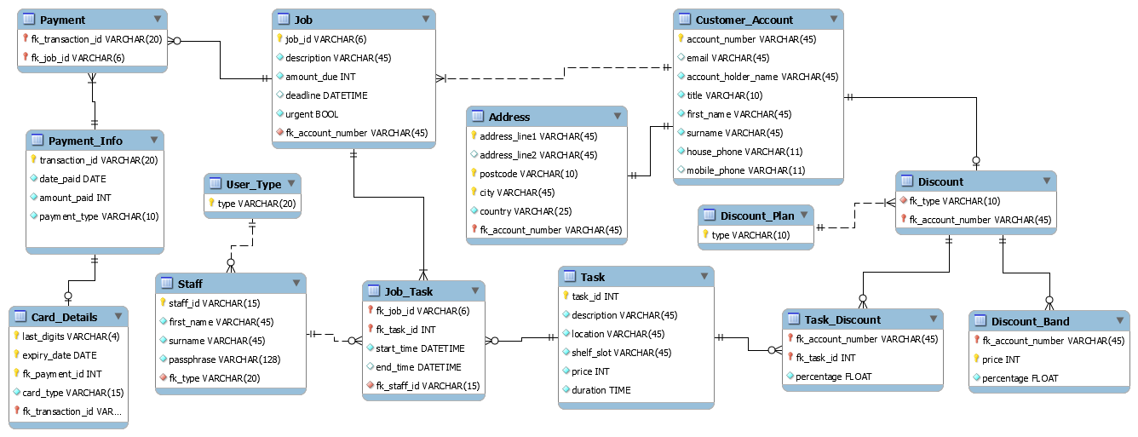

## SQL schema

Below is the schema, including all stored procedures with dummy data necessary for executing reports.

-- MySQL Workbench Forward Engineering

**SET** @OLD_UNIQUE_CHECKS**=**@@UNIQUE_CHECKS**,** UNIQUE_CHECKS**=**0**;**

**SET** @OLD_FOREIGN_KEY_CHECKS**=**@@FOREIGN_KEY_CHECKS**,** FOREIGN_KEY_CHECKS**=**0**;**

**SET** @OLD_SQL_MODE**=**@@SQL_MODE**,** SQL_MODE**=**'TRADITIONAL,ALLOW_INVALID_DATES'**;**

-- -----------------------------------------------------

-- Schema BAPERS

-- -----------------------------------------------------

**DROP** **SCHEMA** **IF** **EXISTS** `BAPERS` **;**

-- -----------------------------------------------------

-- Schema BAPERS

-- -----------------------------------------------------

**CREATE** **SCHEMA** **IF** **NOT** **EXISTS** `BAPERS` **DEFAULT** **CHARACTER** **SET** utf8 **;**

**USE** `BAPERS` **;**

-- -----------------------------------------------------

-- Table `BAPERS`.`User_Type`

-- -----------------------------------------------------

**DROP** **TABLE** **IF** **EXISTS** `BAPERS`**.**`User_Type` **;**

**CREATE** **TABLE** **IF** **NOT** **EXISTS** `BAPERS`**.**`User_Type` **(**

`**type**` **VARCHAR(**20**)** **NOT** **NULL,**

**PRIMARY** **KEY** **(**`**type**`**))**

ENGINE **=** InnoDB**;**

-- -----------------------------------------------------

-- Table `BAPERS`.`Staff`

-- -----------------------------------------------------

**DROP** **TABLE** **IF** **EXISTS** `BAPERS`**.**`Staff` **;**

**CREATE** **TABLE** **IF** **NOT** **EXISTS** `BAPERS`**.**`Staff` **(**

`staff_id` **VARCHAR(**15**)** **NOT** **NULL,**

`first_name` **VARCHAR(**45**)** **NOT** **NULL,**

`surname` **VARCHAR(**45**)** **NOT** **NULL,**

`passphrase` **VARCHAR(**128**)** **NOT** **NULL,**

`fk_type` **VARCHAR(**20**)** **NOT** **NULL,**

**PRIMARY** **KEY** **(**`staff_id`**),**

**INDEX** `fk_User_User_Type1_idx` **(**`fk_type` **ASC),**

**UNIQUE** **INDEX** `username_UNIQUE` **(**`staff_id` **ASC),**

**CONSTRAINT** `fk_User_User_Type1`

**FOREIGN** **KEY** **(**`fk_type`**)**

**REFERENCES** `BAPERS`**.**`User_Type` **(**`**type**`**)**

**ON** **DELETE** **NO** ACTION

**ON** **UPDATE** **NO** ACTION**)**

ENGINE **=** InnoDB**;**

-- -----------------------------------------------------

-- Table `BAPERS`.`Customer_Account`

-- -----------------------------------------------------

**DROP** **TABLE** **IF** **EXISTS** `BAPERS`**.**`Customer_Account` **;**

**CREATE** **TABLE** **IF** **NOT** **EXISTS** `BAPERS`**.**`Customer_Account` **(**

`account_number` **VARCHAR(**45**)** **NOT** **NULL,**

`email` **VARCHAR(**45**)** **NULL,**

`account_holder_name` **VARCHAR(**45**)** **NOT** **NULL,**

`title` **VARCHAR(**10**)** **NOT** **NULL,**

`first_name` **VARCHAR(**45**)** **NOT** **NULL,**

`surname` **VARCHAR(**45**)** **NOT** **NULL,**

`house_phone` **VARCHAR(**11**)** **NOT** **NULL,**

`mobile_phone` **VARCHAR(**11**)** **NULL,**

**PRIMARY** **KEY** **(**`account_number`**))**

ENGINE **=** InnoDB**;**

-- -----------------------------------------------------

-- Table `BAPERS`.`Job`

-- -----------------------------------------------------

**DROP** **TABLE** **IF** **EXISTS** `BAPERS`**.**`Job` **;**

**CREATE** **TABLE** **IF** **NOT** **EXISTS** `BAPERS`**.**`Job` **(**

`job_id` **VARCHAR(**6**)** **NOT** **NULL,**

`description` **VARCHAR(**45**)** **NOT** **NULL,**

`amount_due` **INT** **NOT** **NULL,**

`deadline` DATETIME **NULL,**

`urgent` TINYINT**(**1**)** **NOT** **NULL,**

`fk_account_number` **VARCHAR(**45**)** **NOT** **NULL,**

**PRIMARY** **KEY** **(**`job_id`**),**

**INDEX** `fk_Job_Customer_Account1_idx` **(**`fk_account_number` **ASC),**

**CONSTRAINT** `fk_Job_Customer_Account1`

**FOREIGN** **KEY** **(**`fk_account_number`**)**

**REFERENCES** `BAPERS`**.**`Customer_Account` **(**`account_number`**)**

**ON** **DELETE** **NO** ACTION

**ON** **UPDATE** **NO** ACTION**)**

ENGINE **=** InnoDB**;**

-- -----------------------------------------------------

-- Table `BAPERS`.`Payment_Info`

-- -----------------------------------------------------

**DROP** **TABLE** **IF** **EXISTS** `BAPERS`**.**`Payment_Info` **;**

**CREATE** **TABLE** **IF** **NOT** **EXISTS** `BAPERS`**.**`Payment_Info` **(**

`transaction_id` **VARCHAR(**20**)** **NOT** **NULL,**

`date_paid` **DATE** **NOT** **NULL,**

`amount_paid` **INT** **NOT** **NULL,**

`payment_type` **VARCHAR(**10**)** **NOT** **NULL,**

**PRIMARY** **KEY** **(**`transaction_id`**))**

ENGINE **=** InnoDB**;**

-- -----------------------------------------------------

-- Table `BAPERS`.`Card_Details`

-- -----------------------------------------------------

**DROP** **TABLE** **IF** **EXISTS** `BAPERS`**.**`Card_Details` **;**

**CREATE** **TABLE** **IF** **NOT** **EXISTS** `BAPERS`**.**`Card_Details` **(**

`last_digits` **VARCHAR(**4**)** **NOT** **NULL,**

`expiry_date` **DATE** **NOT** **NULL,**

`fk_payment_id` **INT** **NOT** **NULL,**

`card_type` **VARCHAR(**15**)** **NOT** **NULL,**

`fk_transaction_id` **VARCHAR(**20**)** **NOT** **NULL,**

**PRIMARY** **KEY** **(**`last_digits`**,** `expiry_date`**,** `fk_payment_id`**,** `fk_transaction_id`**),**

**INDEX** `fk_Card_Details_Payment_Info1_idx` **(**`fk_transaction_id` **ASC),**

**CONSTRAINT** `fk_Card_Details_Payment_Info1`

**FOREIGN** **KEY** **(**`fk_transaction_id`**)**

**REFERENCES** `BAPERS`**.**`Payment_Info` **(**`transaction_id`**)**

**ON** **DELETE** **NO** ACTION

**ON** **UPDATE** **NO** ACTION**)**

ENGINE **=** InnoDB**;**

-- -----------------------------------------------------

-- Table `BAPERS`.`Address`

-- -----------------------------------------------------

**DROP** **TABLE** **IF** **EXISTS** `BAPERS`**.**`Address` **;**

**CREATE** **TABLE** **IF** **NOT** **EXISTS** `BAPERS`**.**`Address` **(**

`address_line1` **VARCHAR(**45**)** **NOT** **NULL,**

`address_line2` **VARCHAR(**45**)** **NULL,**

`postcode` **VARCHAR(**10**)** **NOT** **NULL,**

`city` **VARCHAR(**45**)** **NOT** **NULL,**

`country` **VARCHAR(**25**)** **NOT** **NULL,**

`fk_account_number` **VARCHAR(**45**)** **NOT** **NULL,**

**PRIMARY** **KEY** **(**`address_line1`**,** `city`**,** `postcode`**,** `fk_account_number`**),**

**INDEX** `fk_Address_Customer_Account1_idx` **(**`fk_account_number` **ASC),**

**CONSTRAINT** `fk_Address_Customer_Account1`

**FOREIGN** **KEY** **(**`fk_account_number`**)**

**REFERENCES** `BAPERS`**.**`Customer_Account` **(**`account_number`**)**

**ON** **DELETE** **NO** ACTION

**ON** **UPDATE** **NO** ACTION**)**

ENGINE **=** InnoDB**;**

-- -----------------------------------------------------

-- Table `BAPERS`.`Task`

-- -----------------------------------------------------

**DROP** **TABLE** **IF** **EXISTS** `BAPERS`**.**`Task` **;**

**CREATE** **TABLE** **IF** **NOT** **EXISTS** `BAPERS`**.**`Task` **(**

`task_id` **INT** **NOT** **NULL,**

`description` **VARCHAR(**45**)** **NOT** **NULL,**

`location` **VARCHAR(**45**)** **NOT** **NULL,**

`shelf_slot` **VARCHAR(**45**)** **NOT** **NULL,**

`price` **INT** **NOT** **NULL,**

`duration` **TIME** **NOT** **NULL,**

**PRIMARY** **KEY** **(**`task_id`**))**

ENGINE **=** InnoDB**;**

-- -----------------------------------------------------

-- Table `BAPERS`.`Discount_Plan`

-- -----------------------------------------------------

**DROP** **TABLE** **IF** **EXISTS** `BAPERS`**.**`Discount_Plan` **;**

**CREATE** **TABLE** **IF** **NOT** **EXISTS** `BAPERS`**.**`Discount_Plan` **(**

`**type**` **VARCHAR(**10**)** **NOT** **NULL,**

**PRIMARY** **KEY** **(**`**type**`**))**

ENGINE **=** InnoDB**;**

-- -----------------------------------------------------

-- Table `BAPERS`.`Job_Task`

-- -----------------------------------------------------

**DROP** **TABLE** **IF** **EXISTS** `BAPERS`**.**`Job_Task` **;**

**CREATE** **TABLE** **IF** **NOT** **EXISTS** `BAPERS`**.**`Job_Task` **(**

`fk_job_id` **VARCHAR(**6**)** **NOT** **NULL,**

`fk_task_id` **INT** **NOT** **NULL,**

`start_time` DATETIME **NOT** **NULL,**

`end_time` DATETIME **NULL,**

`fk_staff_id` **VARCHAR(**15**)** **NOT** **NULL,**

**PRIMARY** **KEY** **(**`fk_job_id`**,** `fk_task_id`**),**

**INDEX** `fk_Job_has_Task_Task1_idx` **(**`fk_task_id` **ASC),**

**INDEX** `fk_Tasks_Staff1_idx` **(**`fk_staff_id` **ASC),**

**INDEX** `fk_Job_Task_Job1_idx` **(**`fk_job_id` **ASC),**

**CONSTRAINT** `fk_Job_has_Task_Task1`

**FOREIGN** **KEY** **(**`fk_task_id`**)**

**REFERENCES** `BAPERS`**.**`Task` **(**`task_id`**)**

**ON** **DELETE** **NO** ACTION

**ON** **UPDATE** **NO** ACTION**,**

**CONSTRAINT** `fk_Tasks_Staff1`

**FOREIGN** **KEY** **(**`fk_staff_id`**)**

**REFERENCES** `BAPERS`**.**`Staff` **(**`staff_id`**)**

**ON** **DELETE** **NO** ACTION

**ON** **UPDATE** **NO** ACTION**,**

**CONSTRAINT** `fk_Job_Task_Job1`

**FOREIGN** **KEY** **(**`fk_job_id`**)**

**REFERENCES** `BAPERS`**.**`Job` **(**`job_id`**)**

**ON** **DELETE** **NO** ACTION

**ON** **UPDATE** **NO** ACTION**)**

ENGINE **=** InnoDB**;**

-- -----------------------------------------------------

-- Table `BAPERS`.`Discount`

-- -----------------------------------------------------

**DROP** **TABLE** **IF** **EXISTS** `BAPERS`**.**`Discount` **;**

**CREATE** **TABLE** **IF** **NOT** **EXISTS** `BAPERS`**.**`Discount` **(**

`fk_type` **VARCHAR(**10**)** **NOT** **NULL,**

`fk_account_number` **VARCHAR(**45**)** **NOT** **NULL,**

**INDEX** `fk_Discount_Discount_Plan1_idx` **(**`fk_type` **ASC),**

**PRIMARY** **KEY** **(**`fk_account_number`**),**

**CONSTRAINT** `fk_Discount_Discount_Plan1`

**FOREIGN** **KEY** **(**`fk_type`**)**

**REFERENCES** `BAPERS`**.**`Discount_Plan` **(**`**type**`**)**

**ON** **DELETE** **NO** ACTION

**ON** **UPDATE** **NO** ACTION**,**

**CONSTRAINT** `fk_Discount_Customer_Account1`

**FOREIGN** **KEY** **(**`fk_account_number`**)**

**REFERENCES** `BAPERS`**.**`Customer_Account` **(**`account_number`**)**

**ON** **DELETE** **NO** ACTION

**ON** **UPDATE** **NO** ACTION**)**

ENGINE **=** InnoDB**;**

-- -----------------------------------------------------

-- Table `BAPERS`.`Task_Discount`

-- -----------------------------------------------------

**DROP** **TABLE** **IF** **EXISTS** `BAPERS`**.**`Task_Discount` **;**

**CREATE** **TABLE** **IF** **NOT** **EXISTS** `BAPERS`**.**`Task_Discount` **(**

`fk_account_number` **VARCHAR(**45**)** **NOT** **NULL,**

`fk_task_id` **INT** **NOT** **NULL,**

`percentage` **FLOAT** **NOT** **NULL,**

**PRIMARY** **KEY** **(**`fk_account_number`**,** `fk_task_id`**),**

**INDEX** `fk_Customer_Account_has_Task_Task1_idx` **(**`fk_task_id` **ASC),**

**INDEX** `fk_Discounts_Discount1_idx` **(**`fk_account_number` **ASC),**

**CONSTRAINT** `fk_Customer_Account_has_Task_Task1`

**FOREIGN** **KEY** **(**`fk_task_id`**)**

**REFERENCES** `BAPERS`**.**`Task` **(**`task_id`**)**

**ON** **DELETE** **NO** ACTION

**ON** **UPDATE** **NO** ACTION**,**

**CONSTRAINT** `fk_Discounts_Discount1`

**FOREIGN** **KEY** **(**`fk_account_number`**)**

**REFERENCES** `BAPERS`**.**`Discount` **(**`fk_account_number`**)**

**ON** **DELETE** **NO** ACTION

**ON** **UPDATE** **NO** ACTION**)**

ENGINE **=** InnoDB**;**

-- -----------------------------------------------------

-- Table `BAPERS`.`Discount_Band`

-- -----------------------------------------------------

**DROP** **TABLE** **IF** **EXISTS** `BAPERS`**.**`Discount_Band` **;**

**CREATE** **TABLE** **IF** **NOT** **EXISTS** `BAPERS`**.**`Discount_Band` **(**

`fk_account_number` **VARCHAR(**45**)** **NOT** **NULL,**

`price` **INT** **NOT** **NULL,**

`percentage` **FLOAT** **NOT** **NULL,**

**PRIMARY** **KEY** **(**`fk_account_number`**,** `price`**),**

**CONSTRAINT** `fk_table1_Discount1`

**FOREIGN** **KEY** **(**`fk_account_number`**)**

**REFERENCES** `BAPERS`**.**`Discount` **(**`fk_account_number`**)**

**ON** **DELETE** **NO** ACTION

**ON** **UPDATE** **NO** ACTION**)**

ENGINE **=** InnoDB**;**

-- -----------------------------------------------------

-- Table `BAPERS`.`Payment`

-- -----------------------------------------------------

**DROP** **TABLE** **IF** **EXISTS** `BAPERS`**.**`Payment` **;**

**CREATE** **TABLE** **IF** **NOT** **EXISTS** `BAPERS`**.**`Payment` **(**

`fk_transaction_id` **VARCHAR(**20**)** **NOT** **NULL,**

`fk_job_id` **VARCHAR(**6**)** **NOT** **NULL,**

**PRIMARY** **KEY** **(**`fk_transaction_id`**,** `fk_job_id`**),**

**INDEX** `fk_Payment_Info_has_Job_Job1_idx` **(**`fk_job_id` **ASC),**

**INDEX** `fk_Payment_Info_has_Job_Payment_Info1_idx` **(**`fk_transaction_id` **ASC),**

**CONSTRAINT** `fk_Payment_Info_has_Job_Payment_Info1`

**FOREIGN** **KEY** **(**`fk_transaction_id`**)**

**REFERENCES** `BAPERS`**.**`Payment_Info` **(**`transaction_id`**)**

**ON** **DELETE** **NO** ACTION

**ON** **UPDATE** **NO** ACTION**,**

**CONSTRAINT** `fk_Payment_Info_has_Job_Job1`

**FOREIGN** **KEY** **(**`fk_job_id`**)**

**REFERENCES** `BAPERS`**.**`Job` **(**`job_id`**)**

**ON** **DELETE** **NO** ACTION

**ON** **UPDATE** **NO** ACTION**)**

ENGINE **=** InnoDB**;**

**USE** `BAPERS` **;**

-- -----------------------------------------------------

-- procedure night_shift

-- -----------------------------------------------------

**USE** `BAPERS`**;**

**DROP** **procedure** **IF** **EXISTS** `BAPERS`**.**`night_shift`**;**

DELIMITER $$

**USE** `BAPERS`$$

**CREATE** **PROCEDURE** night_shift

**(IN** date_start **date,IN** date_end **date)**

**BEGIN**

**call** shift**(**date_start**,**date_end**,**'22:00:00'**,**'05:00:00'**);**

**END**$$

DELIMITER **;**

-- -----------------------------------------------------

-- procedure shift

-- -----------------------------------------------------

**USE** `BAPERS`**;**

**DROP** **procedure** **IF** **EXISTS** `BAPERS`**.**`shift`**;**

DELIMITER $$

**USE** `BAPERS`$$

**CREATE** **PROCEDURE** shift

**(in** date_start **char(**20**),in** date_end **char(**20**),in** shift_start **char(**20**),** **in** shift_end **char(**20**))**

**BEGIN**

**drop** **temporary** **table** **if** **exists** tmp**;**

**BEGIN**

**create** **temporary** **table** tmp

**Select** **date(**job_task**.**start_time**)as** 'Date'**,**

**(select** SEC_TO_TIME**(** **SUM(** TIME_TO_SEC**(** TIMEDIFF**(**Job_Task**.**end_time**,**Job_task**.**start_time**)** **)** **)** **)**

**from** Job_Task

**inner** **join** Task

**on** Job_Task**.**fk_task_id **=** task**.**task_id

**where** task**.**location **=** 'Copy Room' **and** job_task**.**start_time**>=concat(date,**' '**,**shift_start**)** **and** job_task**.**start_time **<** **(IF(**shift_end **=** '05:00:00'**,(SELECT** **concat(DATE_ADD(date,** **INTERVAL** 1 **DAY),**' '**,**shift_end**)),concat(date,**' '**,**shift_end**)))** **and** **if(**shift_end **=**'05:00:00'**,if(date(**job_task**.**start_time**)>date,date(**job_task**.**start_time**)=** **DATE_ADD(date,** **INTERVAL** 1 **DAY),date(**job_task**.**start_time**)** **=** **date),date(**job_task**.**start_time**)** **=** **date)**

**)**

**as** 'Copy_Room'**,**

**(select** SEC_TO_TIME**(** **SUM(** TIME_TO_SEC**(** TIMEDIFF**(**Job_Task**.**end_time**,**Job_task**.**start_time**)** **)** **)** **)**

**from** Job_Task

**inner** **join** Task

**on** Job_Task**.**fk_task_id **=** task**.**task_id

**where** task**.**location **=** 'Development Area' **and** job_task**.**start_time**>=concat(date,**' '**,**shift_start**)** **and** job_task**.**start_time **<** **(IF(**shift_end **=** '05:00:00'**,(SELECT** **concat(DATE_ADD(date,** **INTERVAL** 1 **DAY),**' '**,**shift_end**)),concat(date,**' '**,**shift_end**)))** **and** **if(**shift_end **=**'05:00:00'**,if(date(**job_task**.**start_time**)>date,date(**job_task**.**start_time**)=** **DATE_ADD(date,** **INTERVAL** 1 **DAY),date(**job_task**.**start_time**)** **=** **date),date(**job_task**.**start_time**)** **=** **date)**

**)**

**as** 'Development'**,**

**(select** SEC_TO_TIME**(** **SUM(** TIME_TO_SEC**(** TIMEDIFF**(**Job_Task**.**end_time**,**Job_task**.**start_time**)** **)** **)** **)**

**from** Job_Task

**inner** **join** Task

**on** Job_Task**.**fk_task_id **=** task**.**task_id

**where** task**.**location **=** 'Finishing Room' **and** job_task**.**start_time**>=concat(date,**' '**,**shift_start**)** **and** job_task**.**start_time **<** **(IF(**shift_end **=** '05:00:00'**,(SELECT** **concat(DATE_ADD(date,** **INTERVAL** 1 **DAY),**' '**,**shift_end**)),concat(date,**' '**,**shift_end**)))** **and** **if(**shift_end **=**'05:00:00'**,if(date(**job_task**.**start_time**)>date,date(**job_task**.**start_time**)=** **DATE_ADD(date,** **INTERVAL** 1 **DAY),date(**job_task**.**start_time**)** **=** **date),date(**job_task**.**start_time**)** **=** **date)**

**)**

**as** 'Finishing'**,**

**(select** SEC_TO_TIME**(** **SUM(** TIME_TO_SEC**(** TIMEDIFF**(**Job_Task**.**end_time**,**Job_task**.**start_time**)** **)** **)** **)**

**from** Job_Task

**inner** **join** Task

**on** Job_Task**.**fk_task_id **=** task**.**task_id

**where** task**.**location **=** 'Packing Departments' **and** job_task**.**start_time**>=concat(date,**' '**,**shift_start**)** **and** job_task**.**start_time **<** **(IF(**shift_end **=** '05:00:00'**,(SELECT** **concat(DATE_ADD(date,** **INTERVAL** 1 **DAY),**' '**,**shift_end**)),concat(date,**' '**,**shift_end**)))** **and** **if(**shift_end **=**'05:00:00'**,if(date(**job_task**.**start_time**)>date,date(**job_task**.**start_time**)=** **DATE_ADD(date,** **INTERVAL** 1 **DAY),date(**job_task**.**start_time**)** **=** **date),date(**job_task**.**start_time**)** **=** **date)**

**)**

**as** 'Packing'

**from** Job_Task

**inner** **join** task

**on** Job_task**.**fk_task_id **=** task**.**task_id

**where** **date(**job_task**.**start_time**)** **between** date_start **and** date_end

**group** **by** **date(**job_task**.**start_time**);**

**END;**

**select** **\*** **from** tmp**;**

**select** sec_to_time**(sum(**time_to_sec**(**Copy_room**)))** **as** Copy_room**,**

sec_to_time**(sum(**time_to_sec**(**Development**)))** **as** Development**,**

sec_to_time**(sum(**time_to_sec**(**Finishing**)))** **as** Finishing**,**

sec_to_time**(sum(**time_to_sec**(**Packing**)))** **as** Packing

**from** tmp**;**

**drop** **temporary** **table** **if** **exists** tmp**;**

**END**$$

DELIMITER **;**

-- -----------------------------------------------------

-- procedure day_shift1

-- -----------------------------------------------------

**USE** `BAPERS`**;**

**DROP** **procedure** **IF** **EXISTS** `BAPERS`**.**`day_shift1`**;**

DELIMITER $$

**USE** `BAPERS`$$

**CREATE** **PROCEDURE** day_shift1

**(IN** date_start **date,IN** date_end **date)**

**BEGIN**

**call** shift**(**date_start**,**date_end**,**'05:00:00'**,**'14:30:00'**);**

**END**$$

DELIMITER **;**

-- -----------------------------------------------------

-- procedure day_shift2

-- -----------------------------------------------------

**USE** `BAPERS`**;**

**DROP** **procedure** **IF** **EXISTS** `BAPERS`**.**`day_shift2`**;**

DELIMITER $$

**USE** `BAPERS`$$

**CREATE** **PROCEDURE** day_shift2

**(IN** date_start **date,IN** date_end **date)**

**BEGIN**

**call** shift**(**date_start**,**date_end**,**'14:30:00'**,**'22:00:00'**);**

**END**$$

DELIMITER **;**

-- -----------------------------------------------------

-- procedure summary_shift

-- -----------------------------------------------------

**USE** `BAPERS`**;**

**DROP** **procedure** **IF** **EXISTS** `BAPERS`**.**`summary_shift`**;**

DELIMITER $$

**USE** `BAPERS`$$

**CREATE** **PROCEDURE** summary_shift

**(in** date_start **char(**20**),in** date_end **char(**20**),in** shift_start **char(**20**),** **in** shift_end **char(**20**),in** shift **char(**20**))**

**BEGIN**

**drop** **temporary** **table** **if** **exists** tmp**;**

**drop** **table** **if** **exists** Sum_shift**;**

**BEGIN**

**create** **temporary** **table** tmp

**Select** **date(**job_task**.**start_time**)as** 'Date'**,**

**(select** SEC_TO_TIME**(** **SUM(** TIME_TO_SEC**(** TIMEDIFF**(**Job_Task**.**end_time**,**Job_task**.**start_time**)** **)** **)** **)**

**from** Job_Task

**inner** **join** Task

**on** Job_Task**.**fk_task_id **=** task**.**task_id

**where** task**.**location **=** 'Copy Room' **and** job_task**.**start_time**>=concat(date,**' '**,**shift_start**)** **and** job_task**.**start_time **<** **(IF(**shift_end **=** '05:00:00'**,(SELECT** **concat(DATE_ADD(date,** **INTERVAL** 1 **DAY),**' '**,**shift_end**)),concat(date,**' '**,**shift_end**)))** **and** **if(**shift_end **=**'05:00:00'**,if(date(**job_task**.**start_time**)>date,date(**job_task**.**start_time**)=** **DATE_ADD(date,** **INTERVAL** 1 **DAY),date(**job_task**.**start_time**)** **=** **date),date(**job_task**.**start_time**)** **=** **date)**

**)**

**as** 'Copy_Room'**,**

**(select** SEC_TO_TIME**(** **SUM(** TIME_TO_SEC**(** TIMEDIFF**(**Job_Task**.**end_time**,**Job_task**.**start_time**)** **)** **)** **)**

**from** Job_Task

**inner** **join** Task

**on** Job_Task**.**fk_task_id **=** task**.**task_id

**where** task**.**location **=** 'Development Area' **and** job_task**.**start_time**>=concat(date,**' '**,**shift_start**)** **and** job_task**.**start_time **<** **(IF(**shift_end **=** '05:00:00'**,(SELECT** **concat(DATE_ADD(date,** **INTERVAL** 1 **DAY),**' '**,**shift_end**)),concat(date,**' '**,**shift_end**)))** **and** **if(**shift_end **=**'05:00:00'**,if(date(**job_task**.**start_time**)>date,date(**job_task**.**start_time**)=** **DATE_ADD(date,** **INTERVAL** 1 **DAY),date(**job_task**.**start_time**)** **=** **date),date(**job_task**.**start_time**)** **=** **date)**

**)**

**as** 'Development'**,**

**(select** SEC_TO_TIME**(** **SUM(** TIME_TO_SEC**(** TIMEDIFF**(**Job_Task**.**end_time**,**Job_task**.**start_time**)** **)** **)** **)**

**from** Job_Task

**inner** **join** Task

**on** Job_Task**.**fk_task_id **=** task**.**task_id

**where** task**.**location **=** 'Finishing Room' **and** job_task**.**start_time**>=concat(date,**' '**,**shift_start**)** **and** job_task**.**start_time **<** **(IF(**shift_end **=** '05:00:00'**,(SELECT** **concat(DATE_ADD(date,** **INTERVAL** 1 **DAY),**' '**,**shift_end**)),concat(date,**' '**,**shift_end**)))** **and** **if(**shift_end **=**'05:00:00'**,if(date(**job_task**.**start_time**)>date,date(**job_task**.**start_time**)=** **DATE_ADD(date,** **INTERVAL** 1 **DAY),date(**job_task**.**start_time**)** **=** **date),date(**job_task**.**start_time**)** **=** **date)**

**)**

**as** 'Finishing'**,**

**(select** SEC_TO_TIME**(** **SUM(** TIME_TO_SEC**(** TIMEDIFF**(**Job_Task**.**end_time**,**Job_task**.**start_time**)** **)** **)** **)**

**from** Job_Task

**inner** **join** Task

**on** Job_Task**.**fk_task_id **=** task**.**task_id

**where** task**.**location **=** 'Packing Departments' **and** job_task**.**start_time**>=concat(date,**' '**,**shift_start**)** **and** job_task**.**start_time **<** **(IF(**shift_end **=** '05:00:00'**,(SELECT** **concat(DATE_ADD(date,** **INTERVAL** 1 **DAY),**' '**,**shift_end**)),concat(date,**' '**,**shift_end**)))** **and** **if(**shift_end **=**'05:00:00'**,if(date(**job_task**.**start_time**)>date,date(**job_task**.**start_time**)=** **DATE_ADD(date,** **INTERVAL** 1 **DAY),date(**job_task**.**start_time**)** **=** **date),date(**job_task**.**start_time**)** **=** **date)**

**)**

**as** 'Packing'

**from** Job_Task

**inner** **join** task

**on** Job_task**.**fk_task_id **=** task**.**task_id

**where** **date(**job_task**.**start_time**)** **between** date_start **and** date_end

**group** **by** **date(**job_task**.**start_time**);**

**END;**

**create** **table** Sum_shift **as(**

**select** shift **as** Title**,**

sec_to_time**(sum(**time_to_sec**(**Copy_room**)))** **as** Copy_room**,**

sec_to_time**(sum(**time_to_sec**(**Development**)))** **as** Development**,**

sec_to_time**(sum(**time_to_sec**(**Finishing**)))** **as** Finishing**,**

sec_to_time**(sum(**time_to_sec**(**Packing**)))** **as** Packing

**from** tmp**);**

**drop** **temporary** **table** **if** **exists** tmp**;**

**END**$$

DELIMITER **;**

-- -----------------------------------------------------

-- procedure sum_night_shift

-- -----------------------------------------------------

**USE** `BAPERS`**;**

**DROP** **procedure** **IF** **EXISTS** `BAPERS`**.**`sum_night_shift`**;**

DELIMITER $$

**USE** `BAPERS`$$

**CREATE** **PROCEDURE** sum_night_shift

**(IN** date_start **date,IN** date_end **date)**

**BEGIN**

**call** Summary_Shift**(**date_start**,**date_end**,**'22:00:00'**,**'05:00:00'**,**'Night Shift'**);**

**END**$$

DELIMITER **;**

-- -----------------------------------------------------

-- procedure sum_day_shift2

-- -----------------------------------------------------

**USE** `BAPERS`**;**

**DROP** **procedure** **IF** **EXISTS** `BAPERS`**.**`sum_day_shift2`**;**

DELIMITER $$

**USE** `BAPERS`$$

**CREATE** **PROCEDURE** sum_day_shift2

**(IN** date_start **date,IN** date_end **date)**

**BEGIN**

**call** Summary_shift**(**date_start**,**date_end**,**'14:30:00'**,**'22:00:00'**,**'Day Shift2'**);**

**END**$$

DELIMITER **;**

-- -----------------------------------------------------

-- procedure sum_day_shift1

-- -----------------------------------------------------

**USE** `BAPERS`**;**

**DROP** **procedure** **IF** **EXISTS** `BAPERS`**.**`sum_day_shift1`**;**

DELIMITER $$

**USE** `BAPERS`$$

**CREATE** **PROCEDURE** sum_day_shift1

**(IN** date_start **date,IN** date_end **date)**

**BEGIN**

**call** Summary_Shift**(**date_start**,**date_end**,**'05:00:00'**,**'14:30:00'**,**'Day Shift1'**);**

**END**$$

DELIMITER **;**

-- -----------------------------------------------------

-- procedure summary

-- -----------------------------------------------------

**USE** `BAPERS`**;**

**DROP** **procedure** **IF** **EXISTS** `BAPERS`**.**`summary`**;**

DELIMITER $$

**USE** `BAPERS`$$

**CREATE** **PROCEDURE** summary

**(IN** date_start **date,IN** date_end **date)**

**BEGIN**

**DROP** **temporary** **table** **IF** **EXISTS** Sum_table**;**

**create** **temporary** **table** Sum_table**(**Title **char(**20**),**Copy_Room **time,**Development **time,**Finishing **time,**Packing **time);**

**call** Sum_Day_shift1**(**date_start**,**date_end**);**

**INSERT** **INTO** Sum_table **SELECT** **\*** **FROM** Sum_shift **order** **by** Sum_shift**.**Title**;**

**DROP** **table** **IF** **EXISTS** Sum_shift**;**

**call** Sum_Day_shift2**(**date_start**,**date_end**);**

**INSERT** **INTO** Sum_table **SELECT** **\*** **FROM** Sum_shift **order** **by** Sum_shift**.**Title**;**

**DROP** **table** **IF** **EXISTS** Sum_shift**;**

**call** Sum_night_shift**(**date_start**,**date_end**);**

**INSERT** **INTO** Sum_table **SELECT** **\*** **FROM** Sum_shift **order** **by** Sum_shift**.**Title**;**

**select** **\*** **from** Sum_table**;**

**select**

sec_to_time**(sum(**time_to_sec**(**Copy_room**)))** **as** Copy_room**,**

sec_to_time**(sum(**time_to_sec**(**Development**)))** **as** Development**,**

sec_to_time**(sum(**time_to_sec**(**Finishing**)))** **as** Finishing**,**

sec_to_time**(sum(**time_to_sec**(**Packing**)))** **as** Packing

**from** Sum_table**;**

**DROP** **table** **IF** **EXISTS** Sum_shift**;**

**DROP** **temporary** **table** **IF** **EXISTS** Sum_table**;**

**END**$$

DELIMITER **;**

-- -----------------------------------------------------

-- procedure ipr

-- -----------------------------------------------------

**USE** `BAPERS`**;**

**DROP** **procedure** **IF** **EXISTS** `BAPERS`**.**`ipr`**;**

DELIMITER $$

**USE** `BAPERS`$$

**CREATE** **PROCEDURE** ipr

**(IN** ID **char(**20**))**

**BEGIN**

**DROP** **TEMPORARY** **TABLE** **IF** **exists** IPR1**;**

**Create** **temporary** **table** IPR1 **as**

**select** **concat(**first_name**,**' '**,**surname**)** **as** Name**,**

Job**.**job_id **as** 'Code'**,**

Job_Task**.**fk_task_id **as** 'Task IDs'**,**

Task**.**location **as** 'Department'**,**

**DATE(**Job_Task**.**start_time**)** **as** 'Date'**,**

**TIME(**Job_Task**.**start_time**)** **as** 'Start Time'**,**

TIMEDIFF**(**Job_Task**.**end_time**,**Job_task**.**start_time**)** **as** 'Time Taken'

**from** staff

**inner** **join** job_task

**on** staff**.**staff_id **=** job_task**.**fk_staff_id

**inner** **join** job

**on** job_task**.**fk_job_id **=** job**.**job_id

**inner** **join** task

**on** job_task**.**fk_task_id **=** task**.**task_id

**where** **if(**ID **=** 'all'**,**staff**.**fk_type **=**'technician'**,**staff_id **=** ID**)**

**order** **by** Name**,SUBSTRING_INDEX(**'Start time'**,** " "**,** **-**1**),** **SUBSTRING_INDEX(**'Start time'**,** " "**,** 1**);**

**select** **\*** **from** IPR1**;**

**select** Name**,**sec_to_time**(sum(**time_to_sec**(**`**Time** Taken`**)))** **as** 'Individual Effort' **from** IPR1 **group** **by** Name**;**

**select** sec_to_time**(sum(**time_to_sec**(**`**Time** Taken`**)))** **as** 'Total Effort' **from** IPR1**;**

**DROP** **TEMPORARY** **TABLE** **IF** **exists** IPR1**;**

**END**$$

DELIMITER **;**

**SET** SQL_MODE**=**@OLD_SQL_MODE**;**

**SET** FOREIGN_KEY_CHECKS**=**@OLD_FOREIGN_KEY_CHECKS**;**

**SET** UNIQUE_CHECKS**=**@OLD_UNIQUE_CHECKS**;**

-- -----------------------------------------------------

-- Data for table `BAPERS`.`User_Type`

-- -----------------------------------------------------

**START** **TRANSACTION;**

**USE** `BAPERS`**;**

**INSERT** **INTO** `BAPERS`**.**`User_Type` **(**`**type**`**)** **VALUES** **(**'office manager'**);**

**INSERT** **INTO** `BAPERS`**.**`User_Type` **(**`**type**`**)** **VALUES** **(**'shift manager'**);**

**INSERT** **INTO** `BAPERS`**.**`User_Type` **(**`**type**`**)** **VALUES** **(**'receptionist'**);**

**INSERT** **INTO** `BAPERS`**.**`User_Type` **(**`**type**`**)** **VALUES** **(**'technician'**);**

**COMMIT;**

-- -----------------------------------------------------

-- Data for table `BAPERS`.`Staff`

-- -----------------------------------------------------

**START** **TRANSACTION;**

**USE** `BAPERS`**;**

**INSERT** **INTO** `BAPERS`**.**`Staff` **(**`staff_id`**,** `first_name`**,** `surname`**,** `passphrase`**,** `fk_type`**)** **VALUES** **(**'0000'**,** 'chris'**,** 'stokes'**,** 'b109f3bbbc244eb82441917ed06d618b9008dd09b3befd1b5e07394c706a8bb980b1d7785e5976ec049b46df5f1326af5a2ea6d103fd07c95385ffab0cacbc86'**,** 'office manager'**);**

**INSERT** **INTO** `BAPERS`**.**`Staff` **(**`staff_id`**,** `first_name`**,** `surname`**,** `passphrase`**,** `fk_type`**)** **VALUES** **(**'0001'**,** 'john'**,** 'nash'**,** 'b109f3bbbc244eb82441917ed06d618b9008dd09b3befd1b5e07394c706a8bb980b1d7785e5976ec049b46df5f1326af5a2ea6d103fd07c95385ffab0cacbc86'**,** 'technician'**);**

**INSERT** **INTO** `BAPERS`**.**`Staff` **(**`staff_id`**,** `first_name`**,** `surname`**,** `passphrase`**,** `fk_type`**)** **VALUES** **(**'0002'**,** 'lee'**,** 'hong'**,** 'b109f3bbbc244eb82441917ed06d618b9008dd09b3befd1b5e07394c706a8bb980b1d7785e5976ec049b46df5f1326af5a2ea6d103fd07c95385ffab0cacbc86'**,** 'technician'**);**

**INSERT** **INTO** `BAPERS`**.**`Staff` **(**`staff_id`**,** `first_name`**,** `surname`**,** `passphrase`**,** `fk_type`**)** **VALUES** **(**'0003'**,** 'julie'**,** 'abbot'**,** 'b109f3bbbc244eb82441917ed06d618b9008dd09b3befd1b5e07394c706a8bb980b1d7785e5976ec049b46df5f1326af5a2ea6d103fd07c95385ffab0cacbc86'**,** 'technician'**);**

**INSERT** **INTO** `BAPERS`**.**`Staff` **(**`staff_id`**,** `first_name`**,** `surname`**,** `passphrase`**,** `fk_type`**)** **VALUES** **(**'0004'**,** 'marina'**,** 'scott'**,** 'b109f3bbbc244eb82441917ed06d618b9008dd09b3befd1b5e07394c706a8bb980b1d7785e5976ec049b46df5f1326af5a2ea6d103fd07c95385ffab0cacbc86'**,** 'technician'**);**

**INSERT** **INTO** `BAPERS`**.**`Staff` **(**`staff_id`**,** `first_name`**,** `surname`**,** `passphrase`**,** `fk_type`**)** **VALUES** **(**'0005'**,** 'stewart'**,** 'pask'**,** 'b109f3bbbc244eb82441917ed06d618b9008dd09b3befd1b5e07394c706a8bb980b1d7785e5976ec049b46df5f1326af5a2ea6d103fd07c95385ffab0cacbc86'**,** 'technician'**);**

**INSERT** **INTO** `BAPERS`**.**`Staff` **(**`staff_id`**,** `first_name`**,** `surname`**,** `passphrase`**,** `fk_type`**)** **VALUES** **(**'0006'**,** 'rich'**,** 'evans'**,** 'b109f3bbbc244eb82441917ed06d618b9008dd09b3befd1b5e07394c706a8bb980b1d7785e5976ec049b46df5f1326af5a2ea6d103fd07c95385ffab0cacbc86'**,** 'office manager'**);**

**COMMIT;**

-- -----------------------------------------------------

-- Data for table `BAPERS`.`Customer_Account`

-- -----------------------------------------------------

**START** **TRANSACTION;**

**USE** `BAPERS`**;**

**INSERT** **INTO** `BAPERS`**.**`Customer_Account` **(**`account_number`**,** `email`**,** `account_holder_name`**,** `title`**,** `first_name`**,** `surname`**,** `house_phone`**,** `mobile_phone`**)** **VALUES** **(**'acc0001'**,** **NULL,** 'City University'**,** 'prof'**,** 'david'**,** 'rhind'**,** '02070408000'**,** **NULL);**

**INSERT** **INTO** `BAPERS`**.**`Customer_Account` **(**`account_number`**,** `email`**,** `account_holder_name`**,** `title`**,** `first_name`**,** `surname`**,** `house_phone`**,** `mobile_phone`**)** **VALUES** **(**'acc0002'**,** **NULL,** 'AirVia Ltd'**,** 'mr'**,** 'boris'**,** 'berezovsky'**,** '02073218523'**,** **NULL);**

**INSERT** **INTO** `BAPERS`**.**`Customer_Account` **(**`account_number`**,** `email`**,** `account_holder_name`**,** `title`**,** `first_name`**,** `surname`**,** `house_phone`**,** `mobile_phone`**)** **VALUES** **(**'acc0003'**,** **NULL,** 'InfoPharma Ltd'**,** 'mr'**,** 'alex'**,** 'wright'**,** '02073218001'**,** **NULL);**

**COMMIT;**

-- -----------------------------------------------------

-- Data for table `BAPERS`.`Job`

-- -----------------------------------------------------

**START** **TRANSACTION;**

**USE** `BAPERS`**;**

**INSERT** **INTO** `BAPERS`**.**`Job` **(**`job_id`**,** `description`**,** `amount_due`**,** `deadline`**,** `urgent`**,** `fk_account_number`**)** **VALUES** **(**'abn54'**,** '5 x 4 B& W copy negatives'**,** 1900**,** **NULL,** **false,** 'acc0001'**);**

**INSERT** **INTO** `BAPERS`**.**`Job` **(**`job_id`**,** `description`**,** `amount_due`**,** `deadline`**,** `urgent`**,** `fk_account_number`**)** **VALUES** **(**'acn54'**,** '5 x 4 Colour copy negatives '**,** 1900**,** **NULL,** **false,** 'acc0001'**);**

**INSERT** **INTO** `BAPERS`**.**`Job` **(**`job_id`**,** `description`**,** `amount_due`**,** `deadline`**,** `urgent`**,** `fk_account_number`**)** **VALUES** **(**'act108'**,** '10 x 8 Colour copy transparency'**,** 9600**,** **NULL,** **false,** 'acc0001'**);**

**INSERT** **INTO** `BAPERS`**.**`Job` **(**`job_id`**,** `description`**,** `amount_due`**,** `deadline`**,** `urgent`**,** `fk_account_number`**)** **VALUES** **(**'act35'**,** '35 mm Colour copy transparency'**,** 2000**,** **NULL,** **false,** 'acc0001'**);**

**INSERT** **INTO** `BAPERS`**.**`Job` **(**`job_id`**,** `description`**,** `amount_due`**,** `deadline`**,** `urgent`**,** `fk_account_number`**)** **VALUES** **(**'b108'**,** '10 x 8 processing'**,** 830**,** **NULL,** **false,** 'acc0001'**);**

**INSERT** **INTO** `BAPERS`**.**`Job` **(**`job_id`**,** `description`**,** `amount_due`**,** `deadline`**,** `urgent`**,** `fk_account_number`**)** **VALUES** **(**'c108'**,** '10 x 8 C41 processing'**,** 830**,** **NULL,** **false,** 'acc0001'**);**

**INSERT** **INTO** `BAPERS`**.**`Job` **(**`job_id`**,** `description`**,** `amount_due`**,** `deadline`**,** `urgent`**,** `fk_account_number`**)** **VALUES** **(**'abc123'**,** 'Test1'**,** 1010**,** **NULL,** **false,** 'acc0002'**);**

**INSERT** **INTO** `BAPERS`**.**`Job` **(**`job_id`**,** `description`**,** `amount_due`**,** `deadline`**,** `urgent`**,** `fk_account_number`**)** **VALUES** **(**'def123'**,** 'Test2'**,** 2020**,** **NULL,** **false,** 'acc0002'**);**

**COMMIT;**

-- -----------------------------------------------------

-- Data for table `BAPERS`.`Address`

-- -----------------------------------------------------

**START** **TRANSACTION;**

**USE** `BAPERS`**;**

**INSERT** **INTO** `BAPERS`**.**`Address` **(**`address_line1`**,** `address_line2`**,** `postcode`**,** `city`**,** `country`**,** `fk_account_number`**)** **VALUES** **(**'northhampton square'**,** **NULL,** 'ec1v 0hb'**,** 'london'**,** 'england'**,** 'acc0001'**);**

**INSERT** **INTO** `BAPERS`**.**`Address` **(**`address_line1`**,** `address_line2`**,** `postcode`**,** `city`**,** `country`**,** `fk_account_number`**)** **VALUES** **(**'12 bond street'**,** **NULL,** 'wc1v 8hu'**,** 'london'**,** 'england'**,** 'acc0002'**);**

**INSERT** **INTO** `BAPERS`**.**`Address` **(**`address_line1`**,** `address_line2`**,** `postcode`**,** `city`**,** `country`**,** `fk_account_number`**)** **VALUES** **(**'25 bond street'**,** ''**,** 'wc1v 8ls'**,** 'london'**,** 'england'**,** 'acc0003'**);**

**COMMIT;**

-- -----------------------------------------------------

-- Data for table `BAPERS`.`Task`

-- -----------------------------------------------------

**START** **TRANSACTION;**

**USE** `BAPERS`**;**

**INSERT** **INTO** `BAPERS`**.**`Task` **(**`task_id`**,** `description`**,** `location`**,** `shelf_slot`**,** `price`**,** `duration`**)** **VALUES** **(**1**,** 'use of large copy camera'**,** 'copy room'**,** 'cr25'**,** 1900**,** '02:00:00'**);**

**INSERT** **INTO** `BAPERS`**.**`Task` **(**`task_id`**,** `description`**,** `location`**,** `shelf_slot`**,** `price`**,** `duration`**)** **VALUES** **(**2**,** 'black and white film processing'**,** 'development area'**,** 'dr12'**,** 4950**,** '01:00:00'**);**

**INSERT** **INTO** `BAPERS`**.**`Task` **(**`task_id`**,** `description`**,** `location`**,** `shelf_slot`**,** `price`**,** `duration`**)** **VALUES** **(**3**,** 'bag up'**,** 'packing departments'**,** 'pr10'**,** 600**,** '30:00'**);**

**INSERT** **INTO** `BAPERS`**.**`Task` **(**`task_id`**,** `description`**,** `location`**,** `shelf_slot`**,** `price`**,** `duration`**)** **VALUES** **(**4**,** 'colour film processing'**,** 'development area'**,** 'dr25'**,** 8000**,** '01:30:00'**);**

**INSERT** **INTO** `BAPERS`**.**`Task` **(**`task_id`**,** `description`**,** `location`**,** `shelf_slot`**,** `price`**,** `duration`**)** **VALUES** **(**5**,** 'colour transparency processing'**,** 'development area'**,** 'dr100'**,** 11030**,** '03:00:00'**);**

**INSERT** **INTO** `BAPERS`**.**`Task` **(**`task_id`**,** `description`**,** `location`**,** `shelf_slot`**,** `price`**,** `duration`**)** **VALUES** **(**6**,** 'use of small copy camera'**,** 'copy room'**,** 'cr16'**,** 830**,** '01:15:00'**);**

**INSERT** **INTO** `BAPERS`**.**`Task` **(**`task_id`**,** `description`**,** `location`**,** `shelf_slot`**,** `price`**,** `duration`**)** **VALUES** **(**7**,** 'mount transparencies'**,** 'finishing room'**,** 'fr5'**,** 5550**,** '45:00'**);**

**COMMIT;**

-- -----------------------------------------------------

-- Data for table `BAPERS`.`Discount_Plan`

-- -----------------------------------------------------

**START** **TRANSACTION;**

**USE** `BAPERS`**;**

**INSERT** **INTO** `BAPERS`**.**`Discount_Plan` **(**`**type**`**)** **VALUES** **(**'fixed'**);**

**INSERT** **INTO** `BAPERS`**.**`Discount_Plan` **(**`**type**`**)** **VALUES** **(**'variable'**);**

**INSERT** **INTO** `BAPERS`**.**`Discount_Plan` **(**`**type**`**)** **VALUES** **(**'flexible'**);**

**COMMIT;**

-- -----------------------------------------------------

-- Data for table `BAPERS`.`Job_Task`

-- -----------------------------------------------------

**START** **TRANSACTION;**

**USE** `BAPERS`**;**

**INSERT** **INTO** `BAPERS`**.**`Job_Task` **(**`fk_job_id`**,** `fk_task_id`**,** `start_time`**,** `end_time`**,** `fk_staff_id`**)** **VALUES** **(**'abn54'**,** 1**,** '2018-01-13 12:00:00'**,** '2018-01-13 12:20:00'**,** '0001'**);**

**INSERT** **INTO** `BAPERS`**.**`Job_Task` **(**`fk_job_id`**,** `fk_task_id`**,** `start_time`**,** `end_time`**,** `fk_staff_id`**)** **VALUES** **(**'abn54'**,** 2**,** '2018-01-13 12:30:00'**,** '2018-01-13 13:10:00'**,** '0002'**);**

**INSERT** **INTO** `BAPERS`**.**`Job_Task` **(**`fk_job_id`**,** `fk_task_id`**,** `start_time`**,** `end_time`**,** `fk_staff_id`**)** **VALUES** **(**'abn54'**,** 3**,** '2018-01-13 13:20:00'**,** '2018-01-13 13:30:00'**,** '0004'**);**

**INSERT** **INTO** `BAPERS`**.**`Job_Task` **(**`fk_job_id`**,** `fk_task_id`**,** `start_time`**,** `end_time`**,** `fk_staff_id`**)** **VALUES** **(**'acn54'**,** 1**,** '2018-01-13 12:20:00'**,** '2018-01-13 12:55:00'**,** '0001'**);**

**INSERT** **INTO** `BAPERS`**.**`Job_Task` **(**`fk_job_id`**,** `fk_task_id`**,** `start_time`**,** `end_time`**,** `fk_staff_id`**)** **VALUES** **(**'acn54'**,** 4**,** '2018-01-13 13:10:00'**,** '2018-01-13 13:50:00'**,** '0002'**);**

**INSERT** **INTO** `BAPERS`**.**`Job_Task` **(**`fk_job_id`**,** `fk_task_id`**,** `start_time`**,** `end_time`**,** `fk_staff_id`**)** **VALUES** **(**'acn54'**,** 3**,** '2018-01-13 14:00:00'**,** '2018-01-13 14:10:00'**,** '0003'**);**

**INSERT** **INTO** `BAPERS`**.**`Job_Task` **(**`fk_job_id`**,** `fk_task_id`**,** `start_time`**,** `end_time`**,** `fk_staff_id`**)** **VALUES** **(**'act108'**,** 1**,** '2018-01-13 12:55:00'**,** '2018-01-13 14:35:00'**,** '0001'**);**

**INSERT** **INTO** `BAPERS`**.**`Job_Task` **(**`fk_job_id`**,** `fk_task_id`**,** `start_time`**,** `end_time`**,** `fk_staff_id`**)** **VALUES** **(**'act108'**,** 5**,** '2018-01-13 14:40:00'**,** '2018-01-13 15:10:00'**,** '0002'**);**

**INSERT** **INTO** `BAPERS`**.**`Job_Task` **(**`fk_job_id`**,** `fk_task_id`**,** `start_time`**,** `end_time`**,** `fk_staff_id`**)** **VALUES** **(**'act108'**,** 3**,** '2018-01-13 15:20:00'**,** '2018-01-13 15:30:00'**,** '0003'**);**

**INSERT** **INTO** `BAPERS`**.**`Job_Task` **(**`fk_job_id`**,** `fk_task_id`**,** `start_time`**,** `end_time`**,** `fk_staff_id`**)** **VALUES** **(**'act35'**,** 1**,** '2018-01-13 14:40:00'**,** '2018-01-13 15:00:00'**,** '0001'**);**

**INSERT** **INTO** `BAPERS`**.**`Job_Task` **(**`fk_job_id`**,** `fk_task_id`**,** `start_time`**,** `end_time`**,** `fk_staff_id`**)** **VALUES** **(**'act35'**,** 5**,** '2018-01-13 15:10:00'**,** '2018-01-13 15:30:00'**,** '0002'**);**

**INSERT** **INTO** `BAPERS`**.**`Job_Task` **(**`fk_job_id`**,** `fk_task_id`**,** `start_time`**,** `end_time`**,** `fk_staff_id`**)** **VALUES** **(**'act35'**,** 7**,** '2018-01-13 15:35:00'**,** '2018-01-13 16:00:00'**,** '0003'**);**

**INSERT** **INTO** `BAPERS`**.**`Job_Task` **(**`fk_job_id`**,** `fk_task_id`**,** `start_time`**,** `end_time`**,** `fk_staff_id`**)** **VALUES** **(**'b108'**,** 2**,** '2018-01-13 12:20:00'**,** '2018-01-13 12:50:00'**,** '0005'**);**

**INSERT** **INTO** `BAPERS`**.**`Job_Task` **(**`fk_job_id`**,** `fk_task_id`**,** `start_time`**,** `end_time`**,** `fk_staff_id`**)** **VALUES** **(**'b108'**,** 3**,** '2018-01-13 12:50:00'**,** '2018-01-13 13:00:00'**,** '0003'**);**

**INSERT** **INTO** `BAPERS`**.**`Job_Task` **(**`fk_job_id`**,** `fk_task_id`**,** `start_time`**,** `end_time`**,** `fk_staff_id`**)** **VALUES** **(**'c108'**,** 4**,** '2018-01-13 13:10:00'**,** '2018-01-13 13:30:00'**,** '0005'**);**

**INSERT** **INTO** `BAPERS`**.**`Job_Task` **(**`fk_job_id`**,** `fk_task_id`**,** `start_time`**,** `end_time`**,** `fk_staff_id`**)** **VALUES** **(**'c108'**,** 3**,** '2018-01-13 13:35:00'**,** '2018-01-13 13:45:00'**,** '0003'**);**

**INSERT** **INTO** `BAPERS`**.**`Job_Task` **(**`fk_job_id`**,** `fk_task_id`**,** `start_time`**,** `end_time`**,** `fk_staff_id`**)** **VALUES** **(**'abc123'**,** 1**,** '2018-01-14 13:35:00'**,** '2018-01-14 13:45:00'**,** '0001'**);**

**INSERT** **INTO** `BAPERS`**.**`Job_Task` **(**`fk_job_id`**,** `fk_task_id`**,** `start_time`**,** `end_time`**,** `fk_staff_id`**)** **VALUES** **(**'abc123'**,** 2**,** '2018-01-14 15:35:00'**,** '2018-01-14 16:35:00'**,** '0001'**);**

**INSERT** **INTO** `BAPERS`**.**`Job_Task` **(**`fk_job_id`**,** `fk_task_id`**,** `start_time`**,** `end_time`**,** `fk_staff_id`**)** **VALUES** **(**'abc123'**,** 3**,** '2018-01-14 17:35:00'**,** '2018-01-14 18:35:00'**,** '0003'**);**

**INSERT** **INTO** `BAPERS`**.**`Job_Task` **(**`fk_job_id`**,** `fk_task_id`**,** `start_time`**,** `end_time`**,** `fk_staff_id`**)** **VALUES** **(**'abc123'**,** 4**,** '2018-01-14 19:35:00'**,** '2018-01-14 20:35:00'**,** '0003'**);**

**INSERT** **INTO** `BAPERS`**.**`Job_Task` **(**`fk_job_id`**,** `fk_task_id`**,** `start_time`**,** `end_time`**,** `fk_staff_id`**)** **VALUES** **(**'abc123'**,** 5**,** '2018-01-14 21:35:00'**,** '2018-01-14 22:35:00'**,** '0002'**);**

**INSERT** **INTO** `BAPERS`**.**`Job_Task` **(**`fk_job_id`**,** `fk_task_id`**,** `start_time`**,** `end_time`**,** `fk_staff_id`**)** **VALUES** **(**'abc123'**,** 6**,** '2018-01-14 23:35:00'**,** '2018-01-15 00:35:00'**,** '0002'**);**

**INSERT** **INTO** `BAPERS`**.**`Job_Task` **(**`fk_job_id`**,** `fk_task_id`**,** `start_time`**,** `end_time`**,** `fk_staff_id`**)** **VALUES** **(**'abc123'**,** 7**,** '2018-01-15 00:45:00'**,** '2018-01-15 02:00:00'**,** '0004'**);**

**INSERT** **INTO** `BAPERS`**.**`Job_Task` **(**`fk_job_id`**,** `fk_task_id`**,** `start_time`**,** `end_time`**,** `fk_staff_id`**)** **VALUES** **(**'def123'**,** 1**,** '2018-01-15 05:45:00'**,** '2018-01-15 06:45:00'**,** '0001'**);**

**INSERT** **INTO** `BAPERS`**.**`Job_Task` **(**`fk_job_id`**,** `fk_task_id`**,** `start_time`**,** `end_time`**,** `fk_staff_id`**)** **VALUES** **(**'def123'**,** 2**,** '2018-01-15 07:45:00'**,** '2018-01-15 08:45:00'**,** '0001'**);**

**INSERT** **INTO** `BAPERS`**.**`Job_Task` **(**`fk_job_id`**,** `fk_task_id`**,** `start_time`**,** `end_time`**,** `fk_staff_id`**)** **VALUES** **(**'def123'**,** 3**,** '2018-01-15 14:45:00'**,** '2018-01-15 16:45:00'**,** '0002'**);**

**INSERT** **INTO** `BAPERS`**.**`Job_Task` **(**`fk_job_id`**,** `fk_task_id`**,** `start_time`**,** `end_time`**,** `fk_staff_id`**)** **VALUES** **(**'def123'**,** 4**,** '2018-01-15 16:45:00'**,** '2018-01-15 18:45:00'**,** '0002'**);**

**INSERT** **INTO** `BAPERS`**.**`Job_Task` **(**`fk_job_id`**,** `fk_task_id`**,** `start_time`**,** `end_time`**,** `fk_staff_id`**)** **VALUES** **(**'def123'**,** 5**,** '2018-01-15 22:45:00'**,** '2018-01-15 23:00:00'**,** '0003'**);**

**INSERT** **INTO** `BAPERS`**.**`Job_Task` **(**`fk_job_id`**,** `fk_task_id`**,** `start_time`**,** `end_time`**,** `fk_staff_id`**)** **VALUES** **(**'def123'**,** 6**,** '2018-01-15 23:45:00'**,** '2018-01-16 00:30:00'**,** '0003'**);**

**INSERT** **INTO** `BAPERS`**.**`Job_Task` **(**`fk_job_id`**,** `fk_task_id`**,** `start_time`**,** `end_time`**,** `fk_staff_id`**)** **VALUES** **(**'def123'**,** 7**,** '2018-01-16 00:45:00'**,** '2018-01-16 02:45:00'**,** '0004'**);**

**COMMIT;**

-- -----------------------------------------------------

-- Data for table `BAPERS`.`Discount`

-- -----------------------------------------------------

**START** **TRANSACTION;**

**USE** `BAPERS`**;**

**INSERT** **INTO** `BAPERS`**.**`Discount` **(**`fk_type`**,** `fk_account_number`**)** **VALUES** **(**'fixed'**,** 'acc0001'**);**

**INSERT** **INTO** `BAPERS`**.**`Discount` **(**`fk_type`**,** `fk_account_number`**)** **VALUES** **(**'flexible'**,** 'acc0002'**);**

**INSERT** **INTO** `BAPERS`**.**`Discount` **(**`fk_type`**,** `fk_account_number`**)** **VALUES** **(**'variable'**,** 'acc0003'**);**

**COMMIT;**

-- -----------------------------------------------------

-- Data for table `BAPERS`.`Task_Discount`

-- -----------------------------------------------------

**START** **TRANSACTION;**

**USE** `BAPERS`**;**

**INSERT** **INTO** `BAPERS`**.**`Task_Discount` **(**`fk_account_number`**,** `fk_task_id`**,** `percentage`**)** **VALUES** **(**'acc0002'**,** 1**,** 0.01**);**

**INSERT** **INTO** `BAPERS`**.**`Task_Discount` **(**`fk_account_number`**,** `fk_task_id`**,** `percentage`**)** **VALUES** **(**'acc0002'**,** 2**,** 0.01**);**

**INSERT** **INTO** `BAPERS`**.**`Task_Discount` **(**`fk_account_number`**,** `fk_task_id`**,** `percentage`**)** **VALUES** **(**'acc0002'**,** 3**,** 0**);**

**INSERT** **INTO** `BAPERS`**.**`Task_Discount` **(**`fk_account_number`**,** `fk_task_id`**,** `percentage`**)** **VALUES** **(**'acc0002'**,** 4**,** 0.02**);**

**INSERT** **INTO** `BAPERS`**.**`Task_Discount` **(**`fk_account_number`**,** `fk_task_id`**,** `percentage`**)** **VALUES** **(**'acc0002'**,** 5**,** 0**);**

**INSERT** **INTO** `BAPERS`**.**`Task_Discount` **(**`fk_account_number`**,** `fk_task_id`**,** `percentage`**)** **VALUES** **(**'acc0002'**,** 6**,** 0.02**);**

**COMMIT;**

-- -----------------------------------------------------

-- Data for table `BAPERS`.`Discount_Band`

-- -----------------------------------------------------

**START** **TRANSACTION;**

**USE** `BAPERS`**;**

**INSERT** **INTO** `BAPERS`**.**`Discount_Band` **(**`fk_account_number`**,** `price`**,** `percentage`**)** **VALUES** **(**'acc0003'**,** 0**,** 0**);**

**INSERT** **INTO** `BAPERS`**.**`Discount_Band` **(**`fk_account_number`**,** `price`**,** `percentage`**)** **VALUES** **(**'acc0003'**,** 100000**,** 0.01**);**

**INSERT** **INTO** `BAPERS`**.**`Discount_Band` **(**`fk_account_number`**,** `price`**,** `percentage`**)** **VALUES** **(**'acc0003'**,** 200000**,** 0.02**);**

**INSERT** **INTO** `BAPERS`**.**`Discount_Band` **(**`fk_account_number`**,** `price`**,** `percentage`**)** **VALUES** **(**'acc0001'**,** 0**,** 0.03**);**

**COMMIT;**

## Reports

The reports will utilise the stored procedures that have been detailed above.

### Summary Performance Report

This report requires the ‘night_shift()’, ‘day_shift1()’, ‘day_shift2()’ and ‘summary()’ procedures. Below details how to obtain the correct output.

**call** night_shift**(**'2018-01-13'**,**'2018-01-17'**);**

Create the Night Shift report according to input value with parameter(Start_date,End_date), If End_date values is later then datas date, it will return datas between start_date till the end of the data's date inclusively.

Outcome: Hours on each location according to date and Total hours on each location on period specify by the user in the parameter.

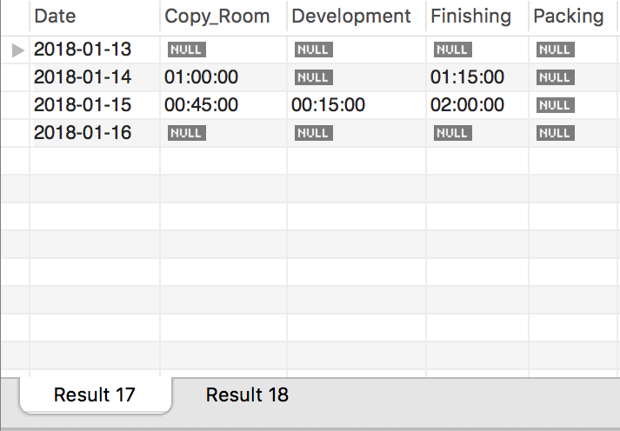

**call** day_shift1**(**'2018-01-13'**,**'2018-01-17'**);**

Create the Day Shift1 report according to input value with parameter(Start_date,End_date), If End_date values is later then datas date, it will return datas between start_date till the end of the data's date inclusively.

Outcome: Hours on each location according to date and Total hours on each location on period specify by the user in the parameter.

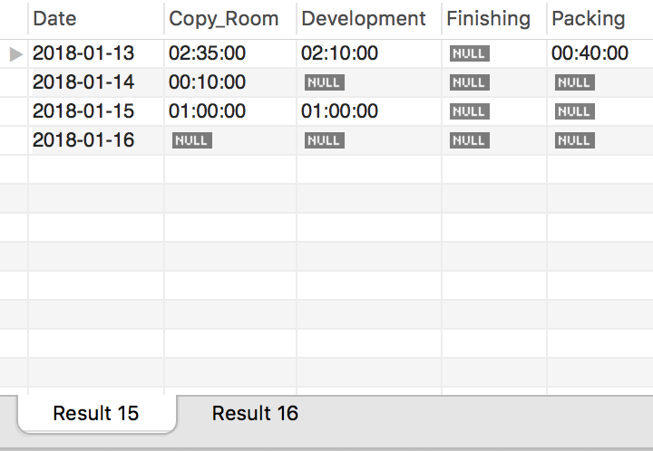

**call** day_shift2**(**'2018-01-13'**,**'2018-01-17'**);**

Create the Day Shift2 report according to input value with parameter(Start_date,End_date), If End_date values is later then datas date, it will return datas between start_date till the end of the data's date inclusively.

Outcome: Hours on each location according to date and Total hours on each location on period specify by the user in the parameter.

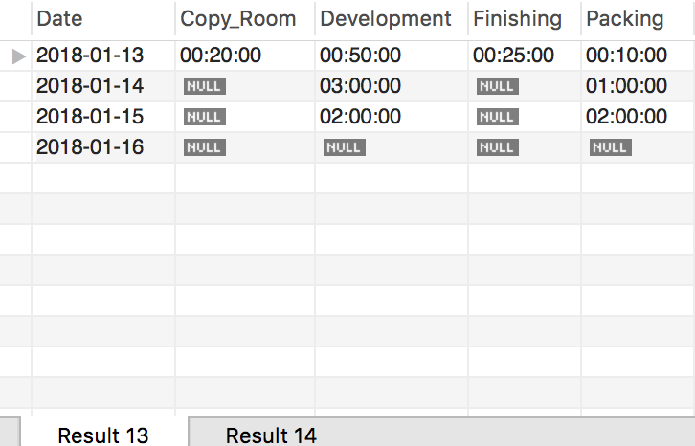

**call** summary**(**'2018-01-13'**,**'2018-01-17'**);**

Create Summary Report according to input value with parameter(Start_date,End_date), if End_date values is later than datas date, it will return dates between Start_date till the end of the data's date inclusively.

Outcome: Total Hours from each Shift from the period specify by the parameter and total hours for each location neglect from which shift.

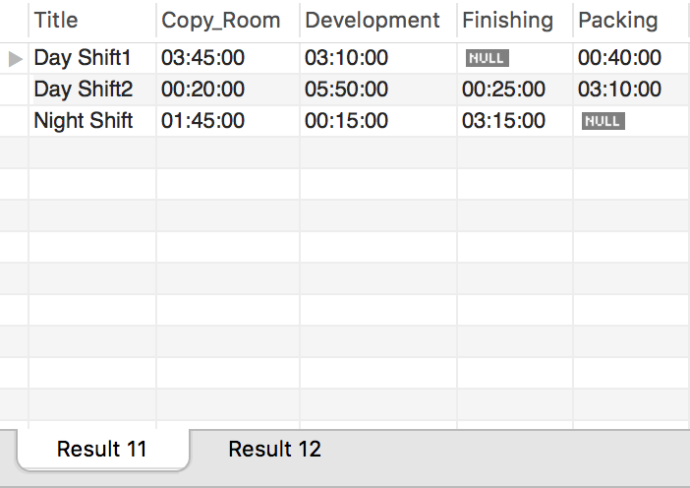

### Individual performance report

**call** ipr**(**'all'**);**

Create Individual Performance Report with parameter(ID), which ID represents the staff_id in the database. User can also input 'all' inside the parameter to get every technician performance report with the total effort for each individual and overall effort which com-bine all individual's hours.

Outcome: Details of the selected individual's job_task, time spend on each task and total time spend on task by selected individual, and total effort(Total time spend on task) from the report generate.)

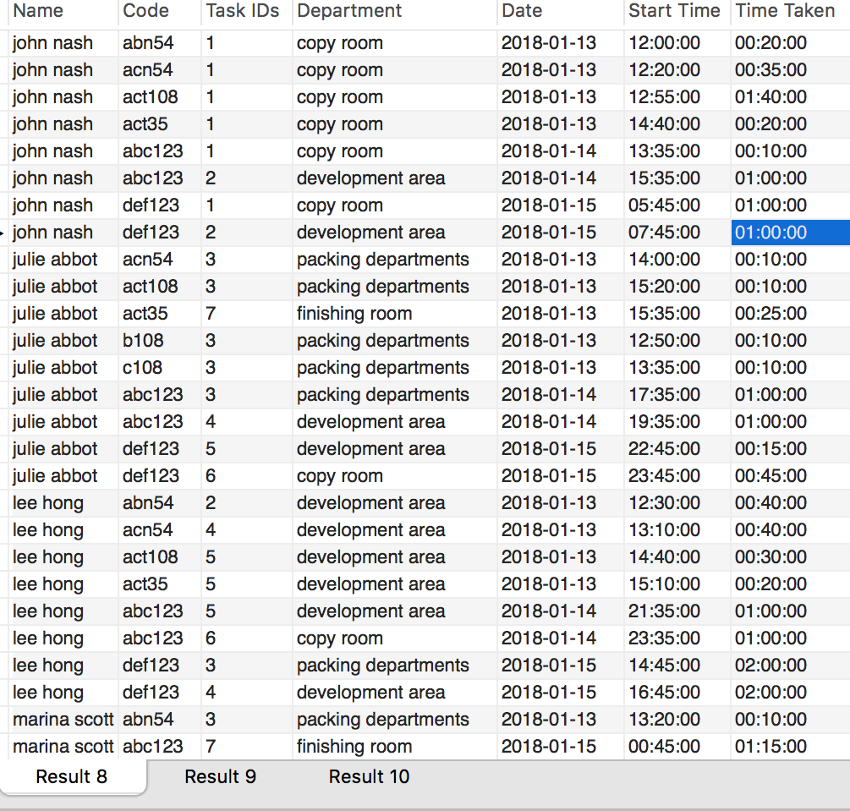

**Graphical User Interface Models**

1. Pages
   1. Page Tree

Home  
 Page 1  
 Page 2  
 Page 3  
 Page 4  
Customer Account  
Intervals  
Backup  
Users  
Report  
Place Order  
Create Account  
Job Process  
Payment  
Tasks

In this section are visual representations of the GUI the users will expect to interact with when they using the BAPERS system. Here are 4 user interfaces one for each user specified (Office Manager, Shift Manager, Receptionist and Technician) and their tasks which are placed on top of each user interface that they interact with.

* 1. Home
     1. User Interface

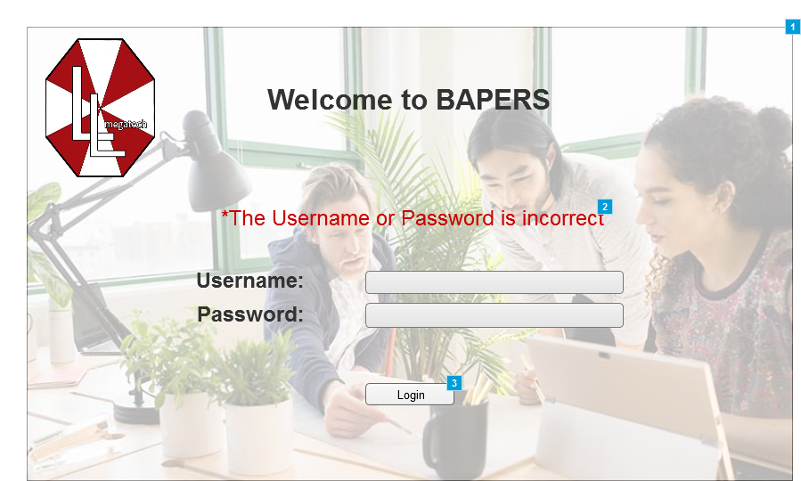

* + 1. Widget Table

|  |  |  |
| --- | --- | --- |
| Footnote | Description | Risk |
| 1 | Main login screen | Low |
| 2 | Text that appears if the login details introduced are wrong |  |
| 3 | When pressed, depending on the user and the details introduced, it either gives access to the system or not. |  |

* 1. Page 1
     1. User Interface

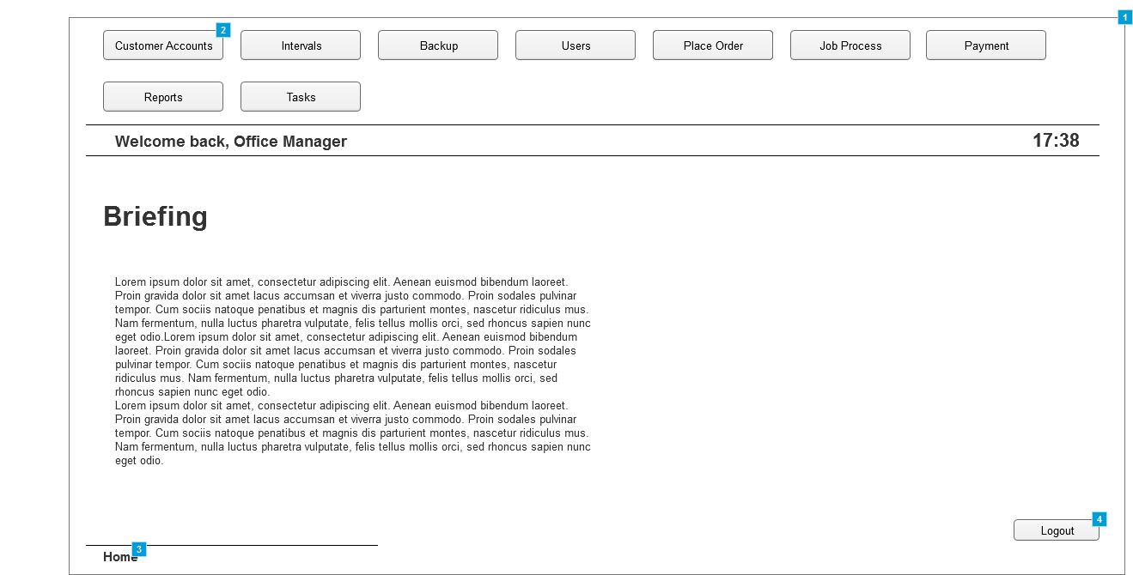

* + 1. Widget Table

| Footnote | Description |
| --- | --- |
| 1 | Home screen panel for the Office Manager |
| 2 | Buttons that when clicked, take the user to the screen described in the tab. Buttons change depending on the users and their permissions |
| 3 | Displays the system path, for easier understanding where in the system the user is located. Can be clicked to go to a previous screen in that path, |
| 4 | Button that, when clicked, logs the user out of the system. |

* 1. Page 2
     1. User Interface

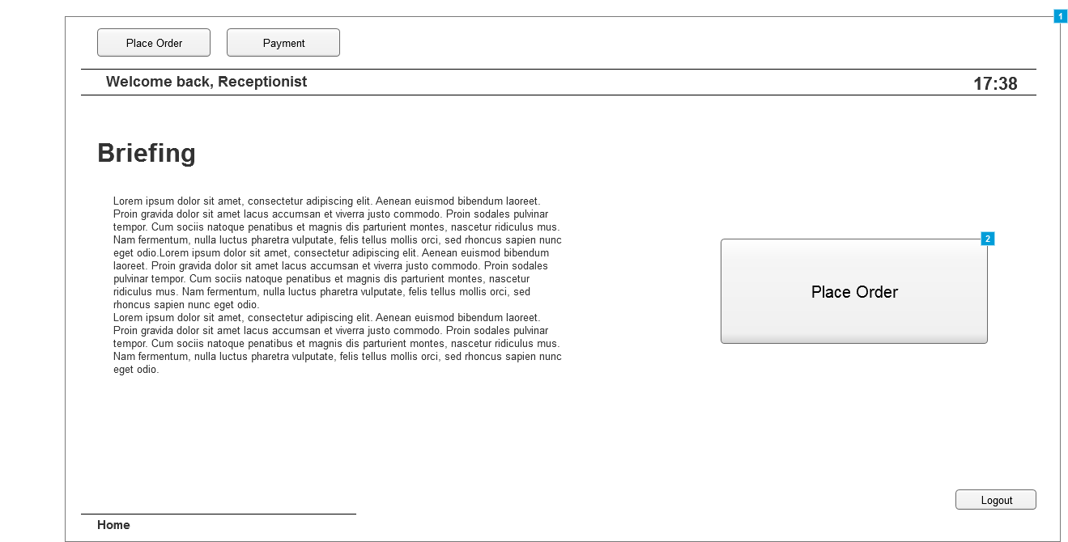

* + 1. Widget Table

| Footnote | Description |
| --- | --- |
| 1 | Home screen panel for the Receptionist |
| 2 | Quick access to "Place Order Tab" since it is one of the main tasks. |

* 1. Page 3
     1. User Interface

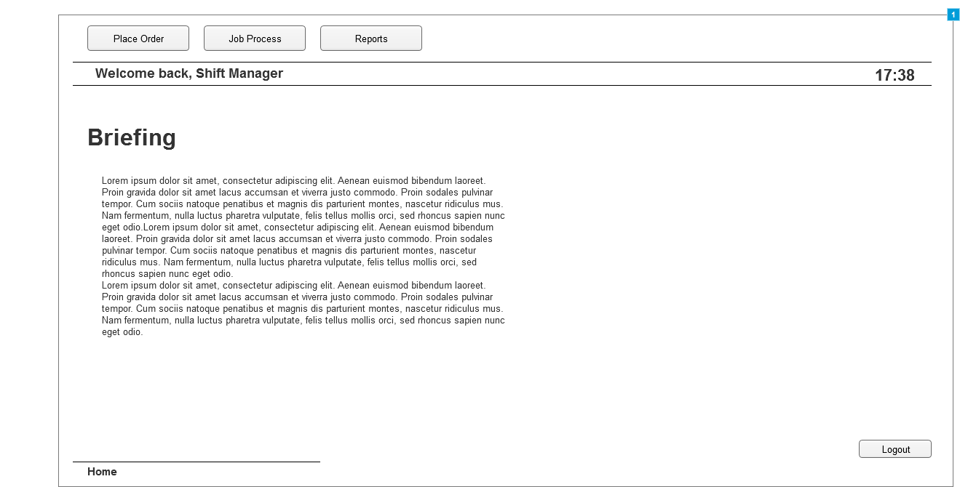

* + 1. Widget Table

| Footnote | Description |
| --- | --- |
| 1 | Home screen panel for the Shift Manager |

* 1. Page 4
     1. User Interface

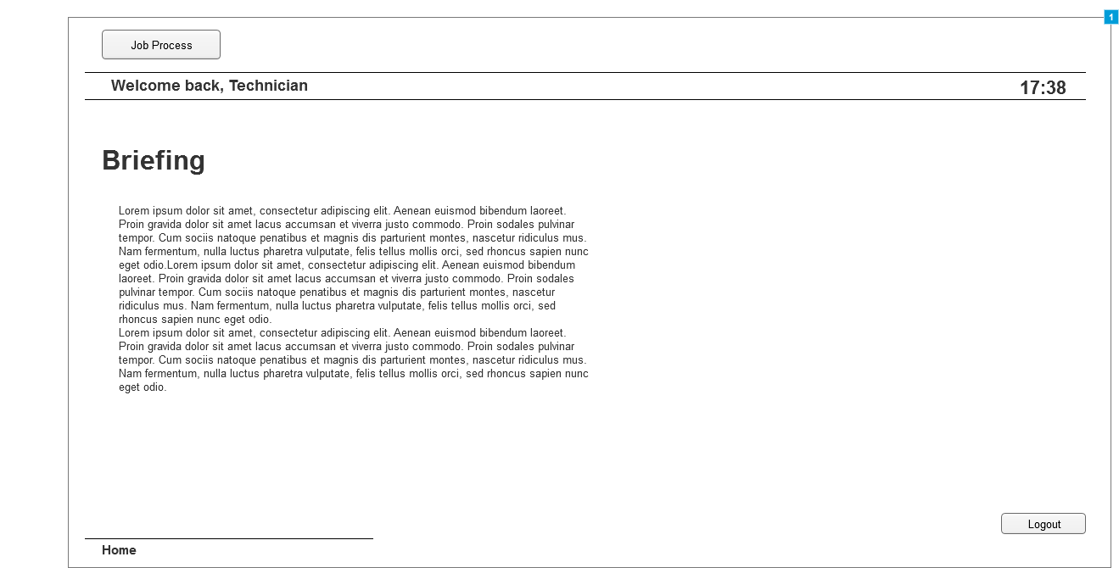

* + 1. Widget Table

| Footnote | Description |
| --- | --- |
| 1 | Home screen panel for the Technician |

* 1. Customer Account
     1. User Interface

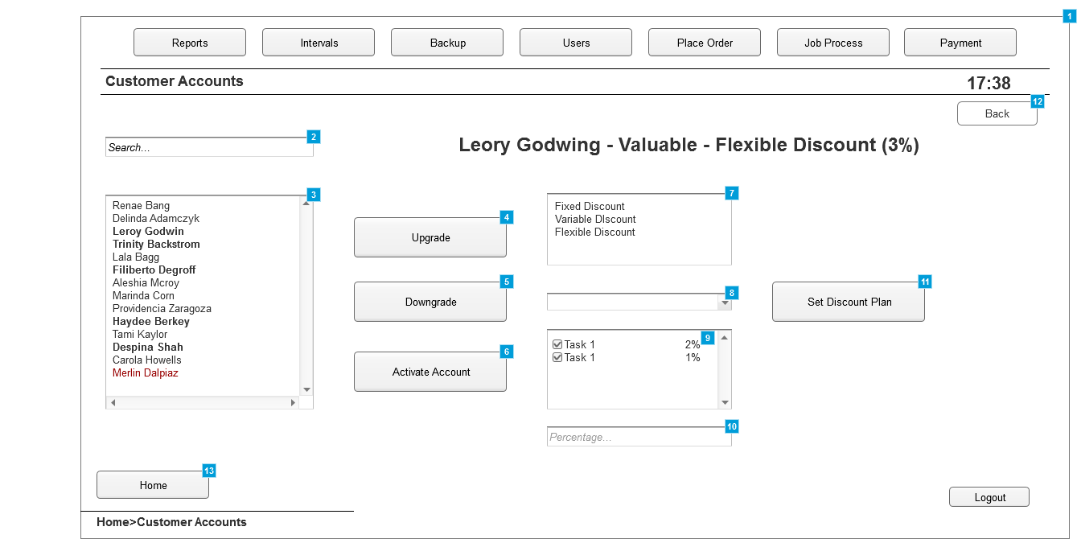

* + 1. Widget Table

| Footnote | Description |
| --- | --- |
| 1 | Panel where the existing customer accounts are managed |
| 2 | Search box, to look-up existing customer accounts, once chosen, upgrading/downgrading options are available as well as updating the discount plans associated with the account |
| 3 | List box where all the existing customer accounts are displayed.   -The ones in Bold Display Valued Customers -The normal ones display normal customers -The ones in red display Suspended Customer Accounts |
| 4 | Upgrades the customer to the "Valued" status, only available if the customer is not already in this status |
| 5 | Downgrades the customer from the "Valued" status to the "Normal" one. |
| 6 | Reactivates a "Suspended" account |
| 7 | Panel displaying the available discount plans |
| 8 | Tab that allows to choose tasks and apply discounts to each one. Appears only if "Flexible Discount" is selected |
| 9 | If a discount for a task need to be deleted, unticking the box will do this. Selecting an existing task from the list and adding a different percentage will overwrite the previous one |
| 10 | The percentage of the discount will be introduced here |
| 11 | Button that, when clicked, confirms the discount options selected |
| 12 | Button that allows the user to go back to the previous screen |
| 13 | Button that takes the user to the home tab |

* 1. Intervals
     1. User Interface

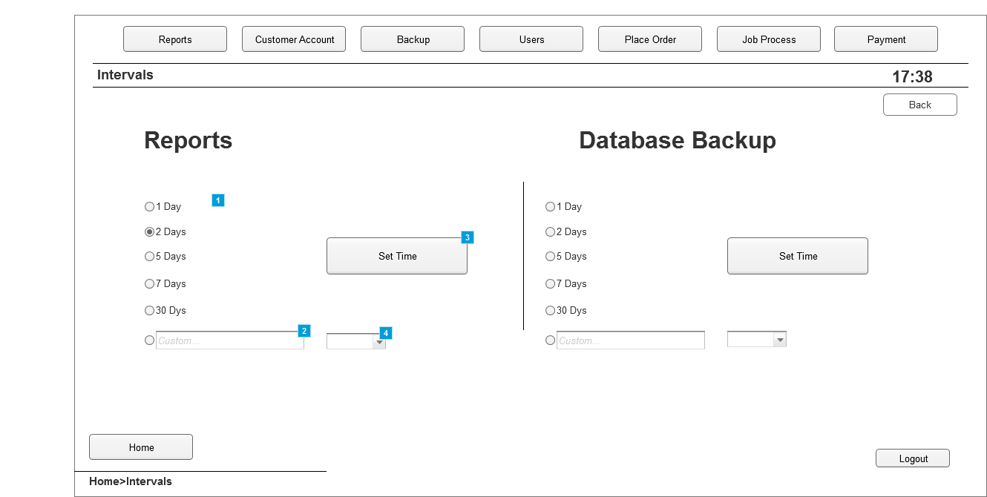

* + 1. Widget Table

| Footnote | Description |
| --- | --- |
| 1 | Premade options to choose the time intervals at which reports are created. Similar for Database Backup |
| 2 | Panel to introduce a custom time period for generating the repots. Same can be done to the Database Backup |
| 3 | Button that, when clicked, sets the time intervals at which reports are created. |
| 4 | Drop list allowing to set minutes, hours or days for the custom time intervals |

* 1. Backup
     1. User Interface

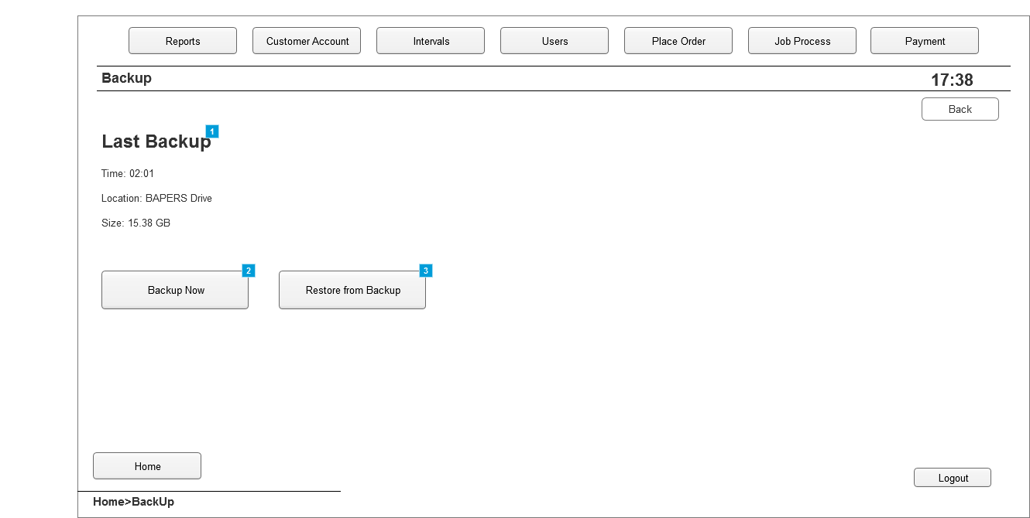

* + 1. Widget Table

| Footnote | Description |
| --- | --- |
| 1 | Information about the last backup created |
| 2 | Button that, when clicked, creates a system backup |
| 3 | Button that, when clicked, restores data from the last backup created |

* 1. Users
     1. User Interface

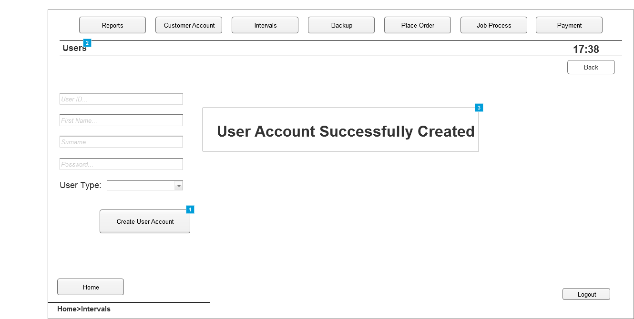

* + 1. Widget Table

| Footnote | Description |
| --- | --- |
| 1 | Button that, when clicked, creates the user account with the details introduced |
| 2 | Tab where new users are added to the system |
| 3 | Window that pops up when an account has been successfully created |

* 1. Report
     1. User Interface

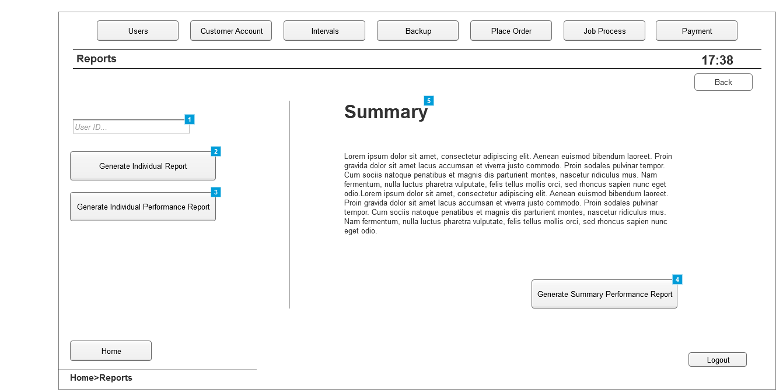

* + 1. Widget Table

| Footnote | Description |
| --- | --- |
| 1 | Box where user ID is introduced. This refers to the system users. Once a user is selected, more options are available |
| 2 | Button that, when clicked, generates an individual report for the user selected |
| 3 | Button that, when clicked, generates an individual performance report for the user selected |
| 4 | Button that, when clicked, generates a summary performance report |
| 5 | Summary and details about it |

* 1. Place Order
     1. User Interface

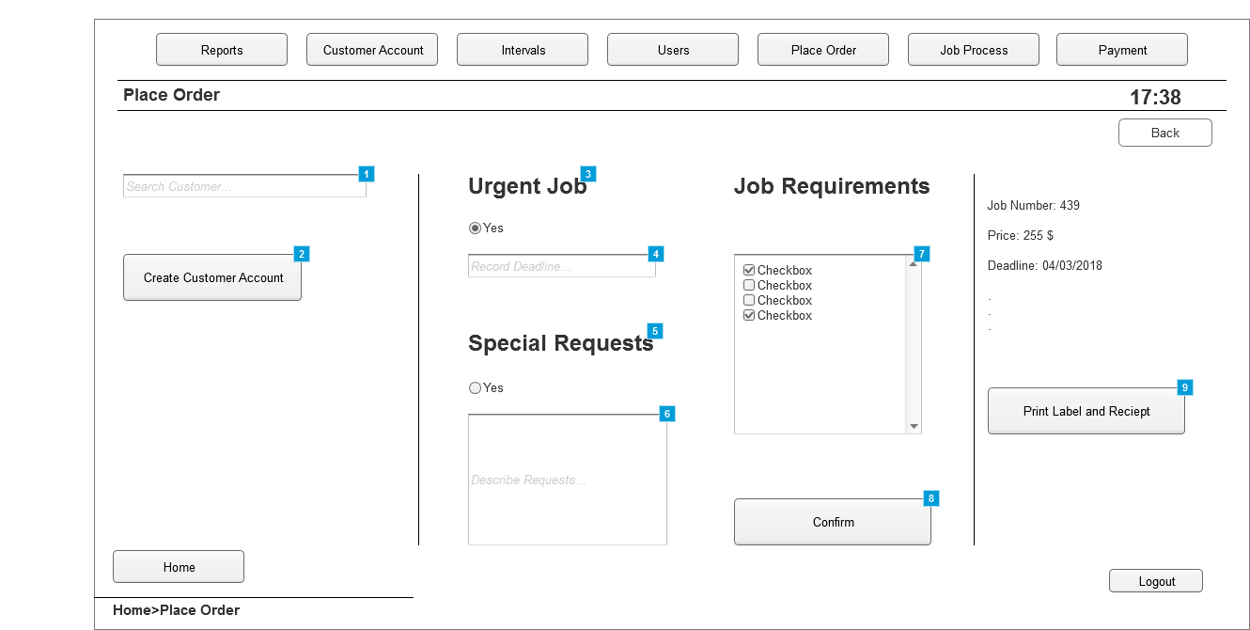

* + 1. Widget Table

| Footnote | Description |
| --- | --- |
| 1 | Panel where customer accounts can be searched, if created, to allow for placing an order |
| 2 | Button that, when clicked, takes the user to the "Create Account" window. Used in case the customer does not have an account yet |
| 3 | Option to select if job placed is urgent. |
| 4 | Panel to introduce deadline if job is urgent |
| 5 | Option to select if special requests exist about the job |
| 6 | Panel to introduce details about the request |
| 7 | List of all tasks available. Checked only the ones which are needed for the job |
| 8 | Button that, when clicked, generates the job number and final price |
| 9 | Button that, when clicked, Assigns the job and prints the label and the reciept. |

* 1. Create Account
     1. User Interface

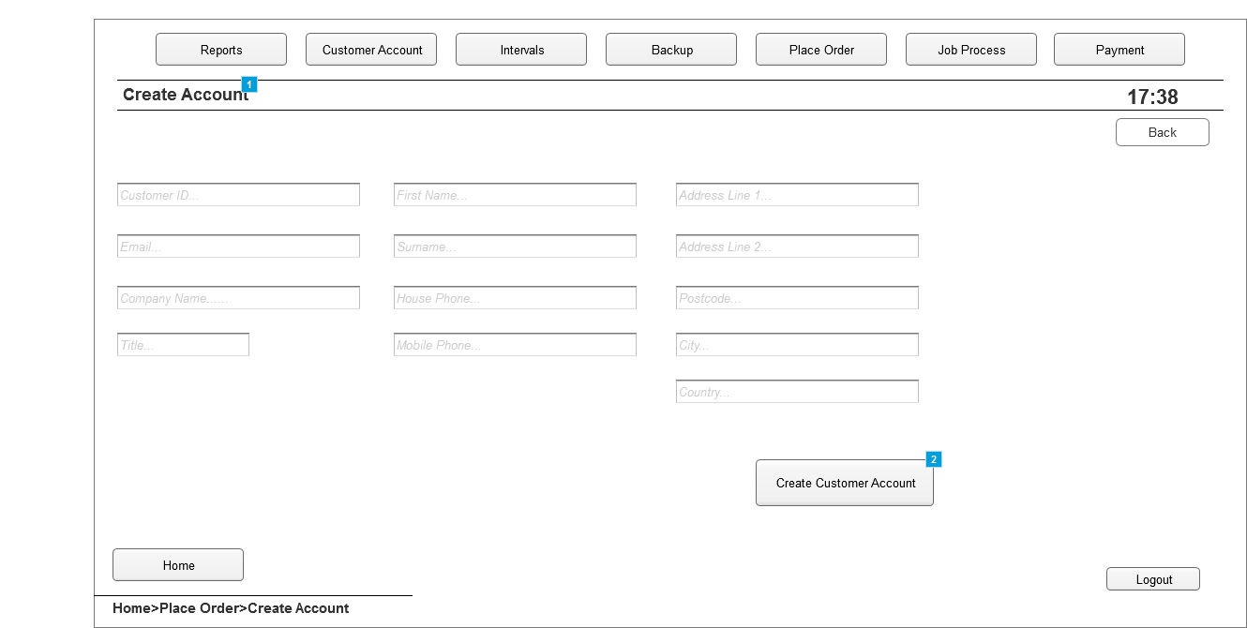

* + 1. Widget Table

| Footnote | Description |
| --- | --- |
| 1 | Tab where new customer accounts are created |
| 2 | Button that, when clicked, creates the customer account with the details introduced in each field. |

* 1. Job Process
     1. User Interface

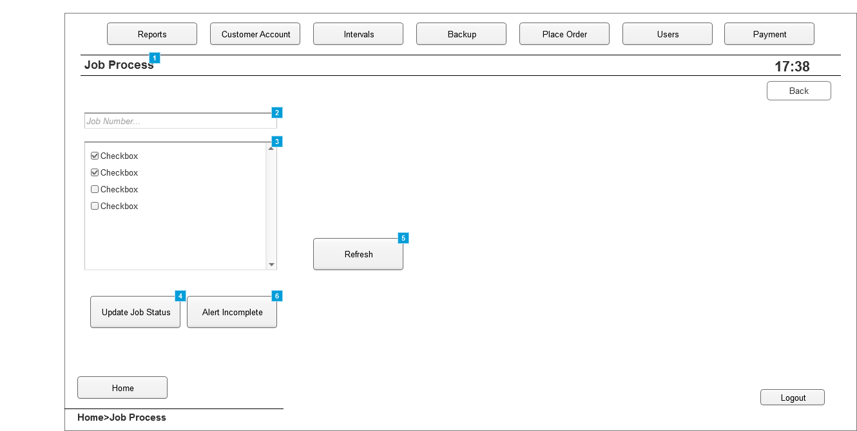

* + 1. Widget Table

| Footnote | Description |
| --- | --- |
| 1 | Tab where the ongoing jobs can be managed |
| 2 | Panel where the job number is introduced to get details about a job |
| 3 | List with the tasks available. Those ticked indicate that the particular task is completed |
| 4 | Button that, when clicked, updates the status of the jobs, A task must be ticked or unticked to be able to update |
| 5 | Button that, when clicked, refreshes the list to see if changes have been made |
| 6 | Button that is click to alert that the job is not going to be completed on time |

* 1. Payment
     1. User Interface

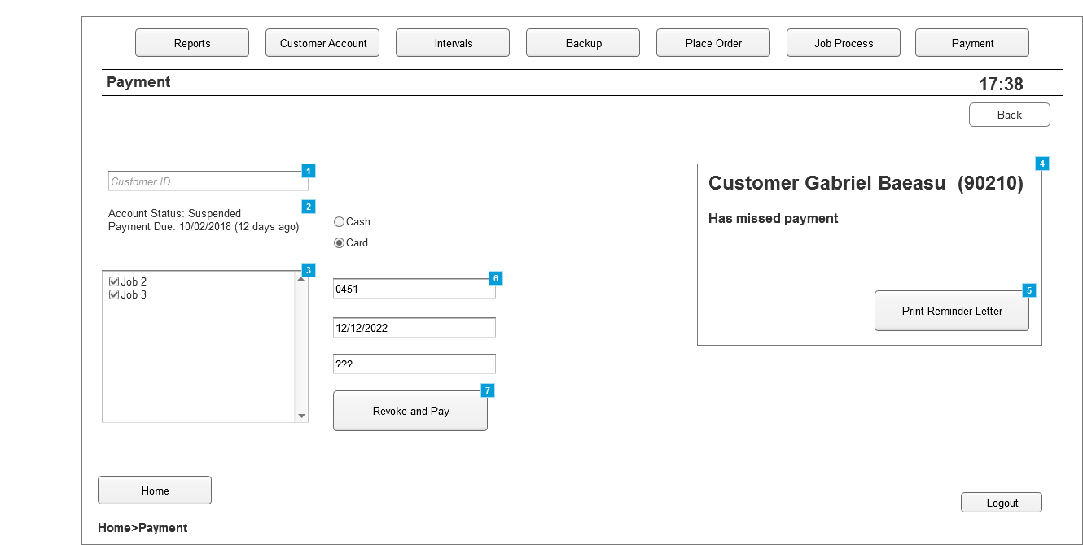

* + 1. Widget Table

| Footnote | Description |
| --- | --- |
| 1 | Panel where a customer is searched to get details about the job placed |
| 2 | Details about the customer account, |
| 3 | List of all the jobs placed, only one will be displayed if the customer is not "Valued"  If the job is ticked, it means it will be paid for in the next payment. |
| 4 | Pop-up window alerting the Office Manager that a customer has missed payment |
| 5 | Button that, when clicked will print the reminder letter for the user |
| 6 | Panels where information about card or cash payment is introduced |
| 7 | Button that, when clicked, completes payment and revokes suspension of an account if account is suspended. |

* 1. Tasks
     1. User Interface

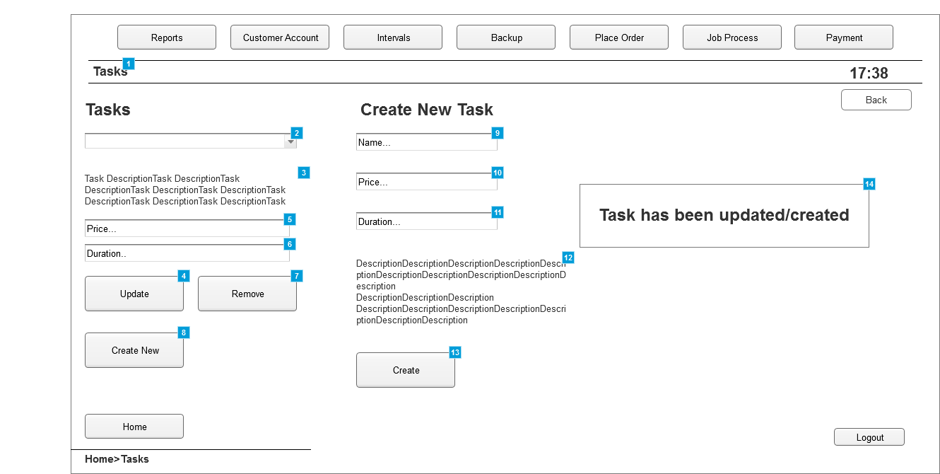

* + 1. Widget Table

| Footnote | Description |
| --- | --- |
| 1 | Tab where tasks can be managed |
| 2 | List of all the tasks available in the system |
| 3 | Description of the task selected |
| 4 | Button that. when clicked, updates any details changed about the selected task |
| 5 | Price of the selected task |
| 6 | Time it takes for the task to be completed |
| 7 | Button that. when clicked, removes the selected task |
| 8 | Button that. when clicked, displays the "Create Task" options |
| 9 | Panel to introduce the name of the new task |
| 10 | Panel to introduce the price of the new task |
| 11 | Panel to introduce the time taken for the new task to be completed |
| 12 | Description of the new task |
| 13 | Button that, when clicked, creates and adds the task to the list of existing tasks. |
| 14 | Window that pops up when a task has been successfully created or updated |